Change Detection Using Satellite Imagery
B-Tech- AI/DS, Semester-VI
Prepared at


Bhaskaracharya National Institute for Space Applications & Geo-informatics
Ministry of Electronics and Information Technology, Govt. of India.
Gandhinagar

Prepared By
Rajyavardhansingh Shekhawat Vivek Rajak
ID No. 26BISAG0503 ID No. 26BISAG0502

Guided By: External Guide:
Dr. Shweta Saharan Dr. Manoj Pandya
Department of AI&DS Additional Director,
GSV, Vadodara BISAG-N, Gandhinagar
SUBMITTED TO
Gati Shakti Vishwavidyalaya



Gati Shakti Vishwavidyalaya - Vadodara


Bhaskaracharya National Institute for Space Applications and Geo-informatics
MeitY, Government of India


दिनांक/Date:_________
यह प्रमाणित किया जाता है कि गति शक्ति विश्वविद्यालय, वडोदरा, गुजरात के छठे सेमेस्टर बीटेक-एआईडीएस के छात्र श्री राज्यवर्धनसिंह शेखावत और श्री विवेक राजक ने बाइसेग-एन में समर इंटर्नशिप सफलतापूर्वक पूरी कर ली है। उन्होंने 18 मई, 2026 से 13 जुलाई, 2026 तक चेंज डिटेक्शन यूज़िंग सैटेलाइट इमेजरी पर काम किया है।

जहाँ तक हमें सूचना है, यह उनके द्वारा किया गया एक मौलिक और प्रामाणिक कार्य है। संस्थान में अपने कार्यकाल के दौरान, उन्होंने आत्म-प्रेरणा और कर्तव्यनिष्ठा का परिचय दिया। हम उनके उज्ज्वल भविष्य की कामना करते हैं।

This is to certify Mr. Rajyavardhansingh Shekhawat and Mr. Vivek Rajak, students of 6th Semester B-Tech-AI/DS from Gati Shakti Vishwavidhyalaya, Vadodara, Gujarat, have satisfactorily completed the summer internship at BISAG-N. They have worked on Change Detection using Satellite Imagery, from May 18th, 2026 to July 13th, 2026.

To the best of our information this is an original and bonafide work done by them. During their tenure at the institute, they demonstrated self-motivation and conscientiousness. We wish them a successful future ahead.

पुनीत लालवानी
Punit Lalwani
अपर निदेशक सह सीआईएसओ
Additional Director cum CISO,
बायसेग-एन, गांधीनगर, गुजरात
BISAG- N, Gandhinagar, Gujarat

डॉ. मनोज पंड्या
Dr. Manoj Pandya
अपर निदेशक
Additional Director,
बायसेग-एन, गांधीनगर, गुजरात
BISAG- N, Gandhinagar, Gujarat

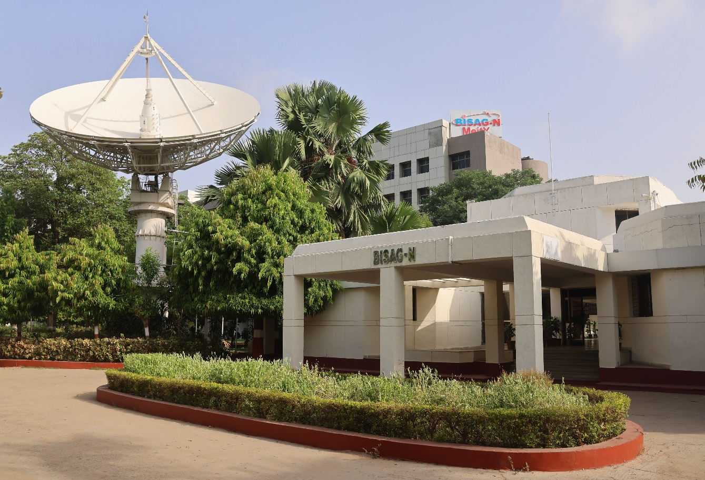
About BISAG-N

Modern day planning for inclusive development and growth calls for transparent, efficient, effective, responsive and low-cost decision-making systems involving multi-disciplinary information such that it not only encourages people's participation, ensuring equitable development but also takes into account the sustainability of natural resources.

The applications of space technology and Geo–informatics have contributed significantly towards the socio-economic development. Taking cognizance of the need of geo-spatial information for developmental planning and management of resources, the department of Ministry of Electronics and Information Technology, Government of India, established "Bhaskaracharya National Institute for Space Applications and Geo-informatics" (BISAG-N).

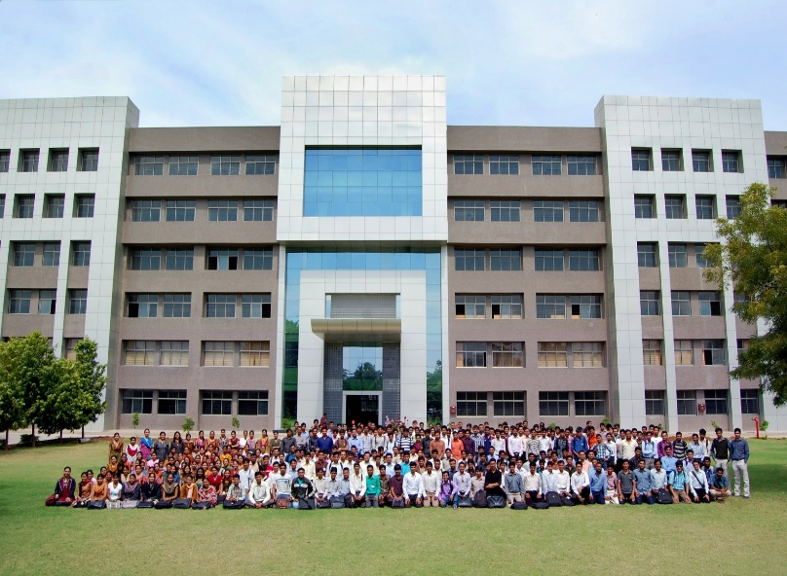
BISAG-N is ISO 9001, ISO 27001, ISO 19115, ISO 19157 and CMMI: L5 certified national institute. BISAG-N, which was initially set up to carry out space technology applications, has evolved into a center of excellence, where research and innovations are combined with the requirements of users and thus acts as a value-added service provider, a technology developer and as a facilitator for providing direct benefits of space technologies to the grass root level functions/functionaries.
BISAG- N Journey
The journey of Institute started as a state government organization, named as Remote Sensing and Communication Centre (RESECO) operating under a limited mandate from 1997 to 2003, focusing on utilization of space technologies such as satellite communication, remote sensing and geospatial applications for supporting various developmental initiatives exclusive for the State of Gujarat. Opinions of various stakeholders at grass root levels was obtained to ensure alignment of Institute's work with the development and welfare need of the society. Numerous sessions of different strata of society were organized including Member of Legislative Assembly (MLAs), village sarpanch, farmers, various skill workers, women and students to obtain insights into what are the needs with simplicity of solutions, and processes of their groups and how technology can fulfil those needs and alleviate any constraints for improving the quality of life.
The basic works of maps generation as per the needs of various state government departments laid the groundwork for the institute’s advancement. In December 2003, the name of the institute changed as BISAG (Bhaskaracharya Institute for Space Applications and Geo-informatics) with an enhanced mandate to promote satellite communication-based education and skill development facility thereby ensuring increased and more actively involvement in governance processes. The name of the institute was changed to honor the celebrated 12th-century mathematician and astronomer, Bhaskaracharya (1114-1185 AD) who provided in-depth insights about various astronomical and mathematical concepts, formulae and calculations.
The institute’s services were extensively utilized by various departments of Gujarat Government under the leadership and patronage of the then Honorable Chief Minister Shri Narendrabhai Modi. Numerous times the assembly meetings were held in BISAG-N premises to amalgamate governance and technology for the well-being of the state. The state leadership expressed to the ministers and bureaucrats on multiple occasions the importance of visualization of development plans and schemes on maps and thereby harnessing the capabilities of BISAG as a "go-to place" for various technological and geo-informatics solutions required by concerned ministries and departments for the benefit of citizens and development of the state.

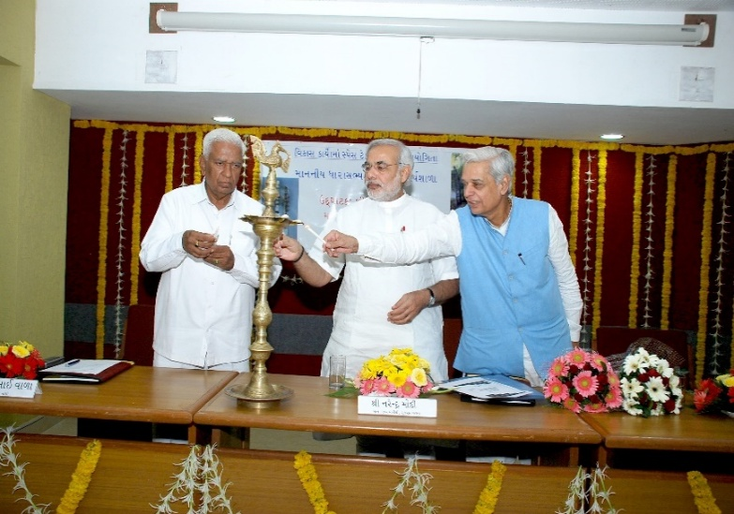
On one of such occasions in 2004, Honorable Chief Minister Shri Narendra Modi said, “Friends, I can clearly visualize that within a span of five years, all streams of government administration shall converge into BISAG. This institute shall be a huge treasure of information, if any decisions are to be taken or any department require any information or need any policy change; the ‘Source of Information’ shall be BISAG. There for earlier we can transform BISAG into a ‘Source of Information’ and position it as back-bone of all governance and administration activities, and the sooner the benefits of science and technology shall be available to the society.”
Since then, inspired by above and gaining insights while working collaboratively for various development initiatives of central and state government department, the Institute is focused on following vision:
“To empower and serve the nation through development of space and geo-spatial technologies, its applications, solutions and services in accordance to governance principles for socio-economic welfare of the society.”
The Institute develops geo-spatial technologies, databases, software and processes along with skilled resources to provide visualization, analysis and decision support system to various state government departments. Also, the Satellite Communication infrastructure was enhanced to add more channels and developed in house expertise to install, operate and maintain various electronic instruments and equipment. The institute constantly ensured adoption of national and international standards as well as best practices to develop and reinforce the solutions delivery process. With the improved confidence and trust of the state government to utilize geo-spatial and satellite communication services for developmental, social welfare and disaster management areas, the institute was supported by the Government of Gujarat to construct dedicated buildings for ensuring services are provided at even larger scale. This expansion broadened the institute’s scope to integrate advanced techniques such as managing large databases, mathematical modelling, enabling prediction and simplified architecture for the solution aligning with the government priorities for improving efficiency, transparency and pace of development
Along with providing the e-governance support to Gujarat State, the institute also started supporting various other states and central government ministries as and when required for map and decision support system development services. Recognizing this potential, the institute’s mandate was further enhanced to cater to the geo-spatial and satellite communication-based e-governance services to all central government ministries as well as various states and union territories as a National institute. The name of the institute was then changed as Bhaskaracharya National Institute for Space Applications and Geo-informatics (BISAG-N), registered as an Autonomous Scientific Society, as per the Societies Registration Act, 1860, under the Ministry of Electronics and Information Technology (MeitY), Government of India (GoI). BISAG-N; enhanced mandate includes to undertake technology development & management; research & development; facilitate national and international cooperation and capacity building; support technology transfer and entrepreneurship development in area of geo-spatial technology.
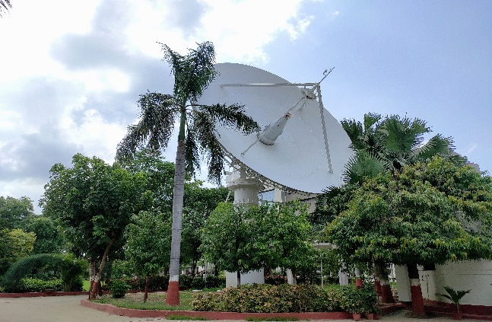
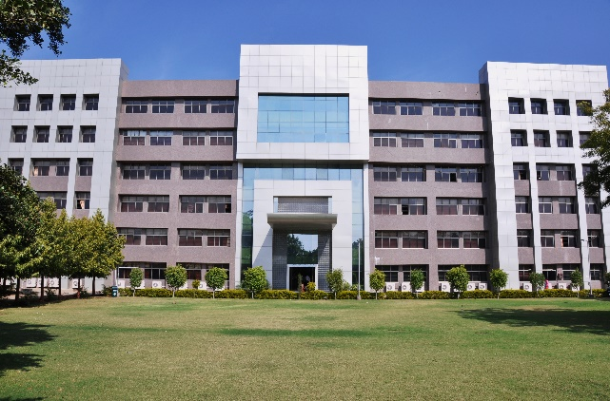
Today, BISAG-N is collaboratively working with 50+ central government ministries and most of the states and union territories for supporting various developmental programs and citizen centric services. BISAG-N provides the technological support to these stakeholders from its Gandhinagar and New Delhi facilities. These facilities have adequate skilled personnel and state-of-the-art infrastructure for providing geo-spatial solutions and software applications including support of satellite communication-based education and training. Thus, BISAG-N is playing pivotal role as a one stop center for providing geo-spatial and space technologies for various flagship programme being undertaken for the development of nation in line with geo-spatial education, logistics and various other policies and program of central and state governments.
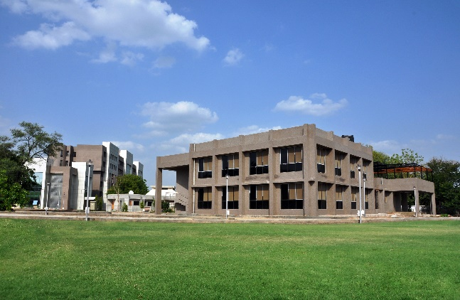
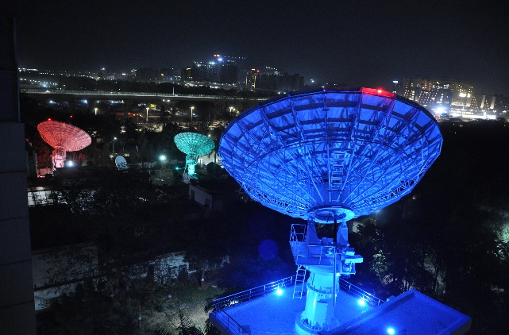
BISAG-N: Major Focus Area
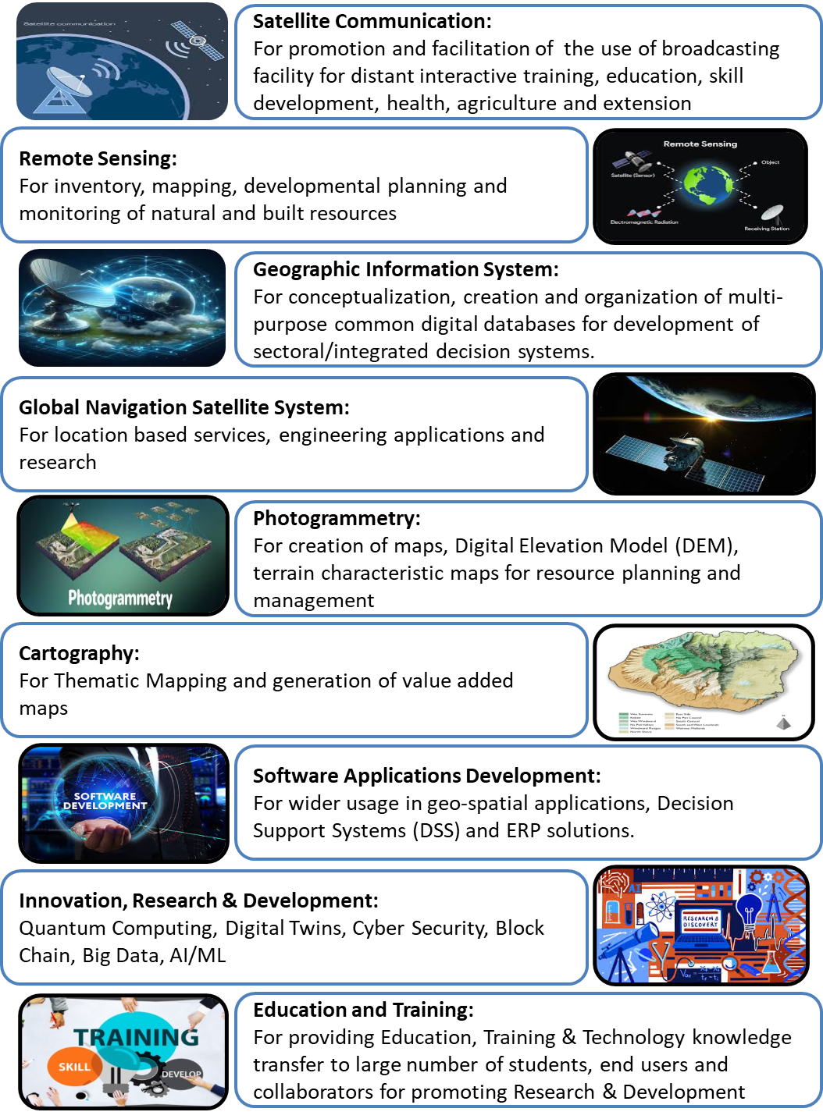
Organizational Setup
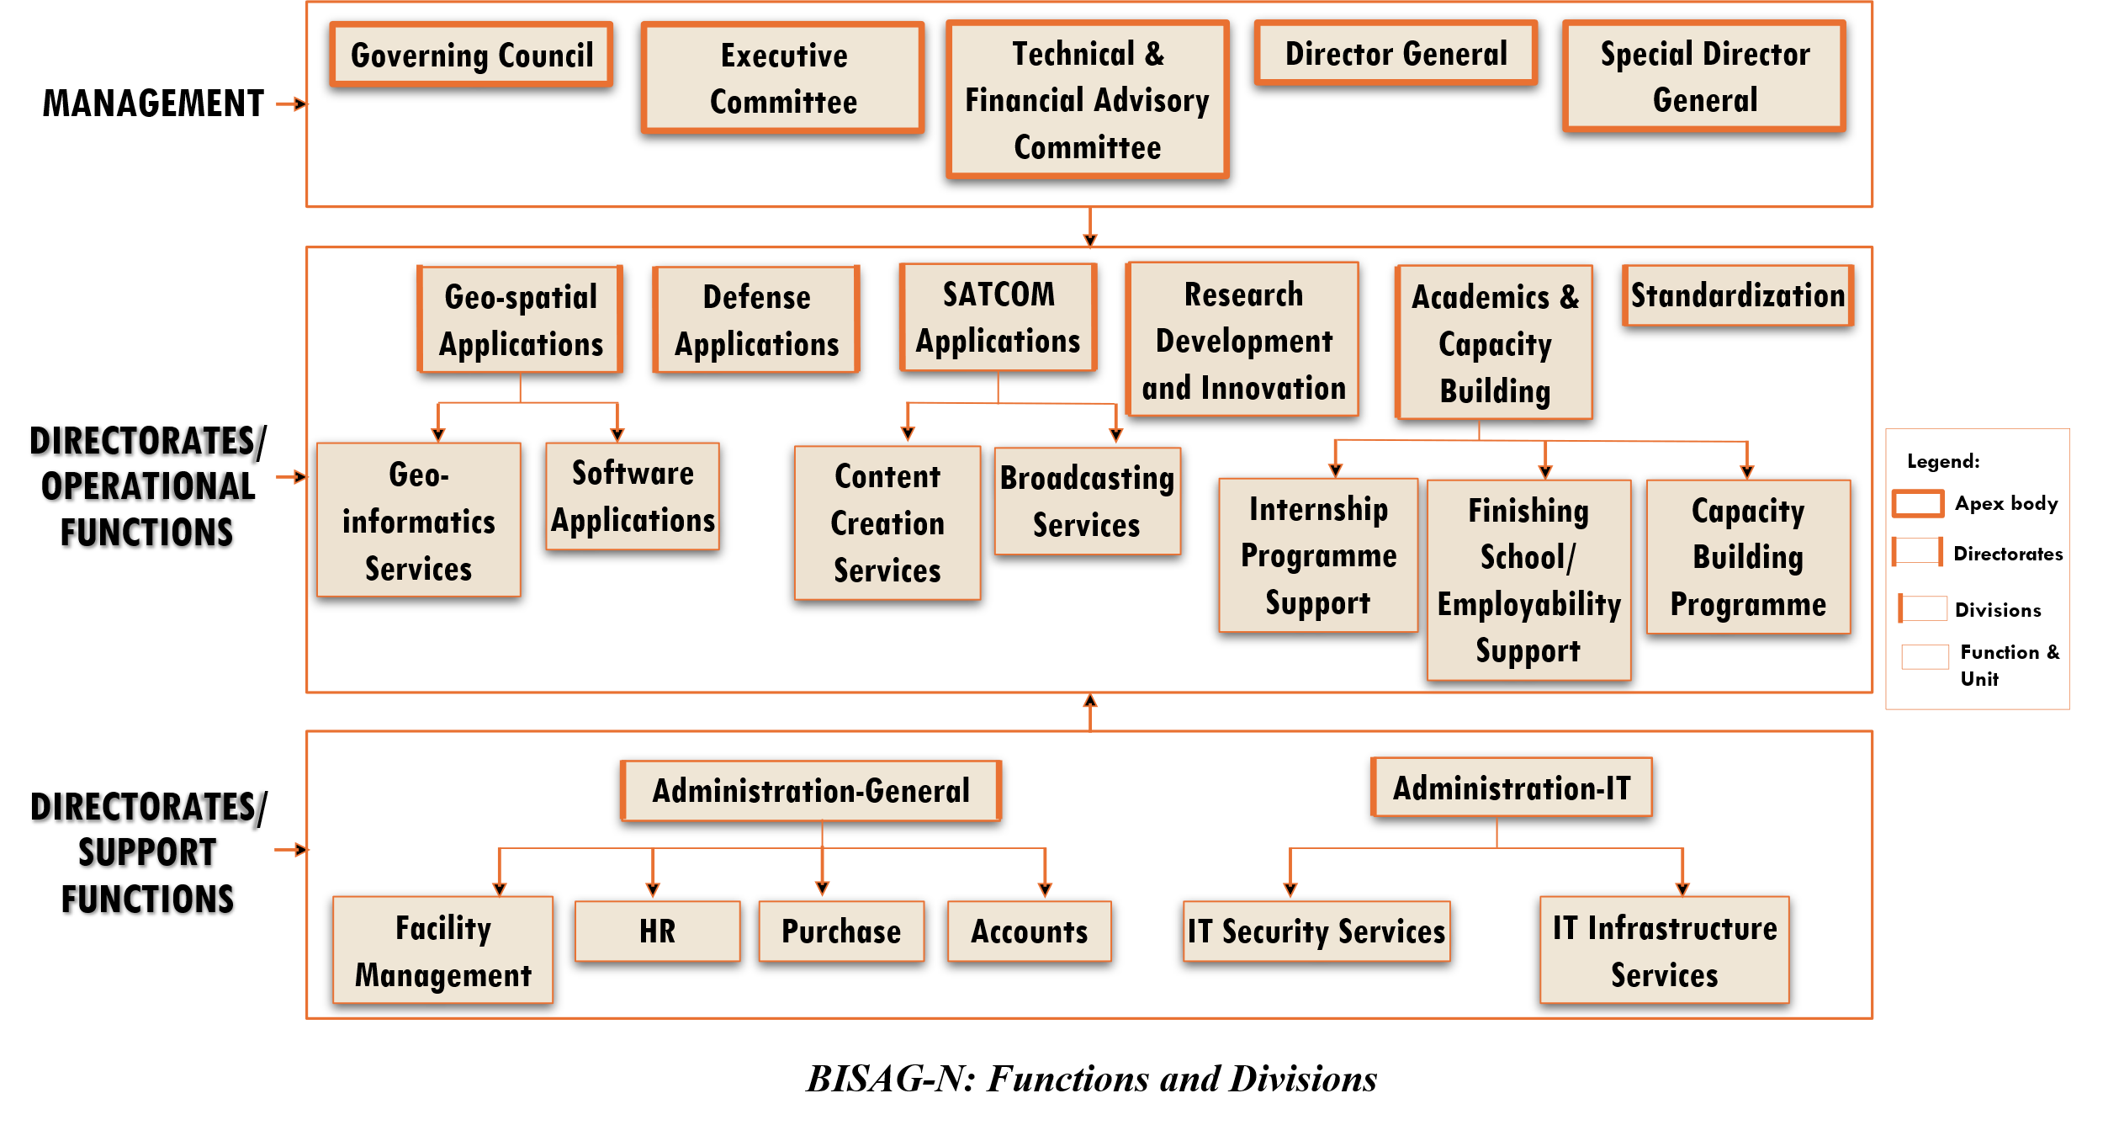
BISAG-N main domain areas include Satellite Communication, Geo-spatial Solutions and Technology Development, Geo-informatics Applications Development, Standardization, Academics & National/ International Co-operation and Administration.
SATCOM Applications
The SATCOM Directorate provides services of distance education, capacity building, training, extension, awareness and empowerment using the state-of-the-art facility comprises of an uplink earth station, control room, studios and a satellite communication-based network. The services are primarily utilized by Ministry of Education and various other central and states ministries. Through Ministry of External Affairs (MoEA), BISAG-N is now poised to provide SATCOM based education to neighbouring countries also.
SATCOM operations are inspired by the wisdom of Hon’ble Prime Minister of India as elicited on numerous occasions. For example, in 2004 as Hon’ble Chief Minister of Gujarat, Shri Modi explained the importance of learning through the ancient way of visualization using virtual media with these words:
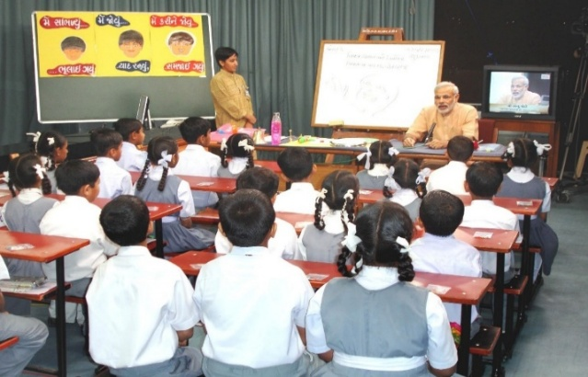
“The way Eklavya studied by making a statue, why we can’t study with the help of a T.V.? Yes, we can. Was any cinema song ever taught to us in any class? Was it ever taught by any teacher? We learnt song from T.V., isn’t it? If we have learnt entire cinema song, learnt every word, learnt scale, learnt rhythm, it means we can learn through T.V. also.”

There are twelve state-of-the-art studios for live recording of content supported by dedicated editing labs, subtitling, translation, animation and various other aspects. The institute has set up ten studios at Gandhinagar facility and another two studios at New Delhi. Infrastructure for transmission and Ku band uplink teleports (11m/9.3m) of more than 350 channels is installed, integrated and maintained by inhouse team. BISAG-N support various initiatives of Ministry of Education, Government of India, as well as other central and state government ministries such as PM e-Vidya, Swayam Prabha etc. as detailed further.
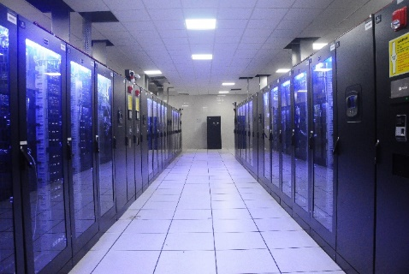
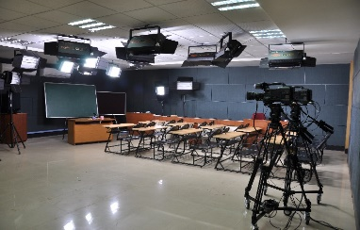

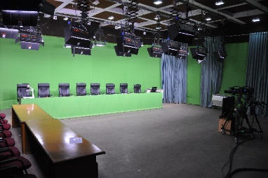
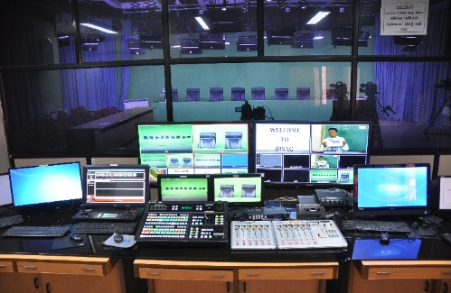

Geo-spatial Applications Directorate
BISAG-N’s Geo-Spatial Applications Directorate provides specialized services and solutions to implement Geographic Information Systems (GIS) for providing impetus to planning and developmental activities at grass root level. The objective of GA directorate is to provide analysis and decision support services to various stakeholders through scientifically organized, comprehensive, multi-purpose, compatible and large scale geo-spatial databases.
Geo-spatial Applications Directorate creates and organizes large-scale and multi-purpose geospatial datasets in collaboration with central and state government departments and agencies. A well-qualified team of GIS technicians and engineers ensure that the datasets are compatible, standardized and authenticated for use in analysis, planning and decision-support functions. Goals and roles of converging organizations are taken into consideration while geo-spatial database creation and software development activities
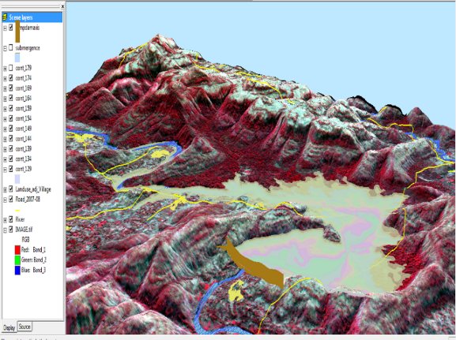
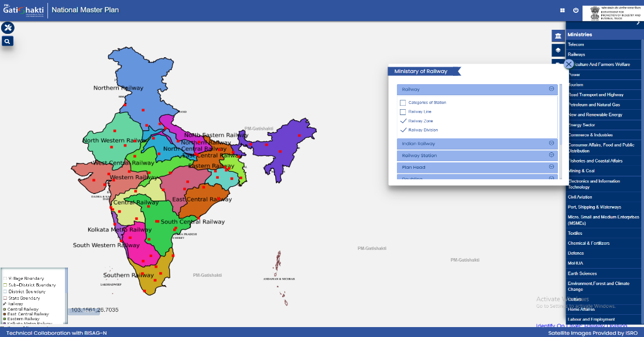

Railway Zones with Divisions

Software Development Division
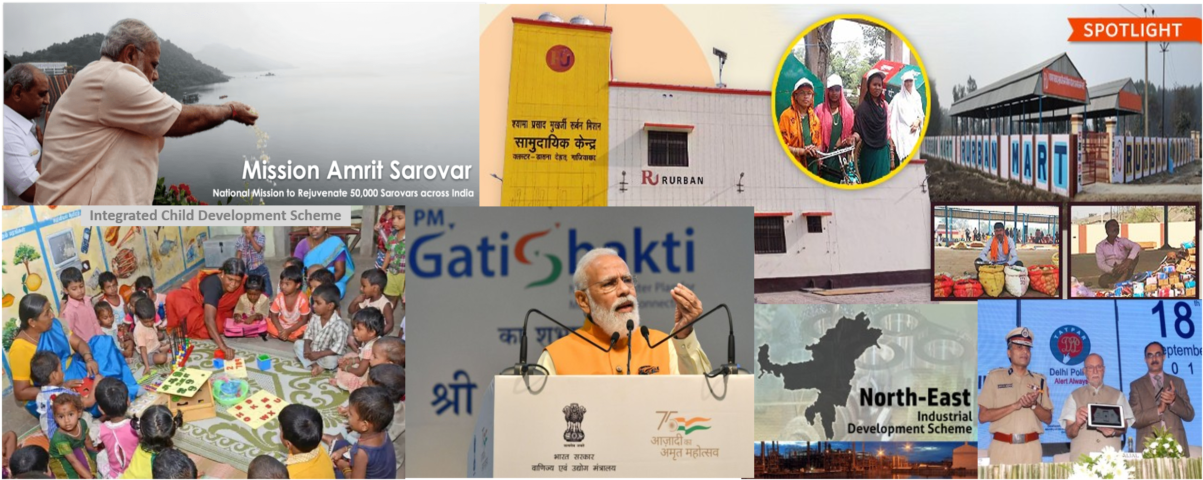
The geo-spatial solutions are packaged and provided as software products for ease of retrieval of spatial and feature attributes data, enabling wide range of analysis, prediction and decision support services. Software technologies like Java, Python, JavaScript, Spring Boot, React JS, Node JS, Microservices, XML, GeoJSON, GeoServer, QGIS, Android and iOS frameworks are used to develop user-friendly and reliable solutions.

Academy of Geo-informatics
BISAG-N, being a national institute for geo-spatial and emerging technology-based applications, has a strong focus on research, development, capacity building and employability support for under-graduate, post-graduate and doctoral students. The institute’s infrastructure and supportive work environment provide an ideal platform for students pursuing thesis work in a variety of technologies and domains.
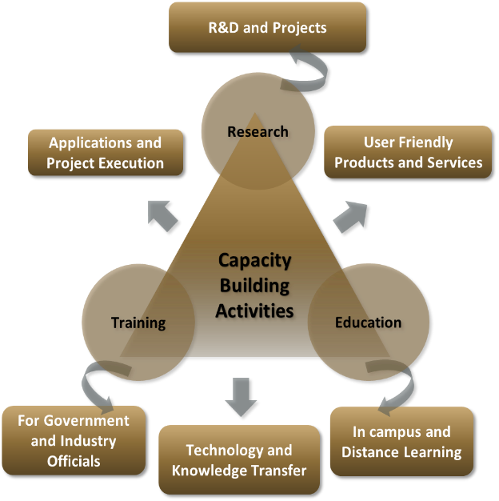
BISAG-N is equipped with cutting-edge infrastructure to support research across multiple disciplines. Dedicated laboratories for research on the application of artificial intelligence, machine learning, GIS (Geographic Information Systems), remote sensing, quantum computing, IoT (Internet of Things) and other emerging technologies are established high-performance computing facilities for intensive data processing tasks are available in the institute. Open-source platforms and in-house developed software are available for projects, research and innovation activities. More than 300 students are supported every year for learning practical based aspects of geo-spatial and emerging technology applications while completing their projects.

BISAG-N Finishing School Programme (FSP) supports wards of special groups of society such as scheduled tribe, scheduled caste, non-gazetted security, armed forces citizens and martyr etc, for development of technical and soft skills to improve their employability including support for entrepreneurship and employment opportunities.
The school provides basic and specialized training to help participants develop capacities as required by the for related industry/domain. The participants undergo thorough counselling sessions as well as mock/actual interviews for improving employability in relevant industries as per the interest of the candidates. Along with the skills training the participants are also allowed to observe engaged in ongoing projects of organization. BISAG-N academic activities also provide capacity building support to government officials for effectively using geo-spatial solutions and decision support systems for performing planning and monitoring for various government schemes and initiatives.
Industrial visits of school students are organized to provide them exposure of space applications and geo-informatics thereby supporting the development of scientific temperament at early stage. More than 5000 students visit the premises every year to get exposure of the activities being carried out at BISAG-N.
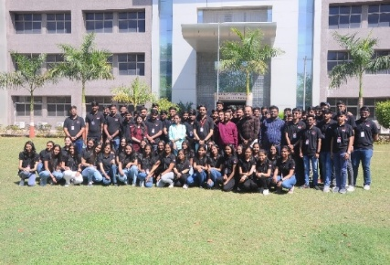
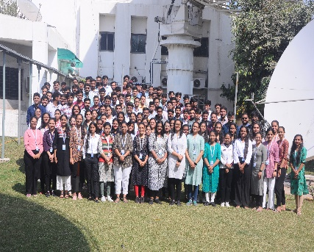
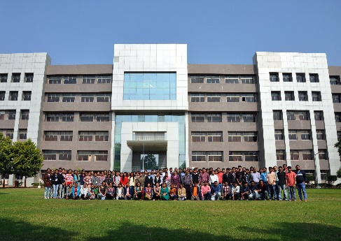
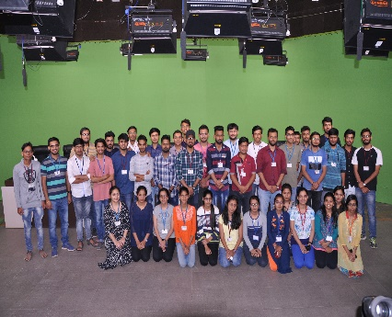
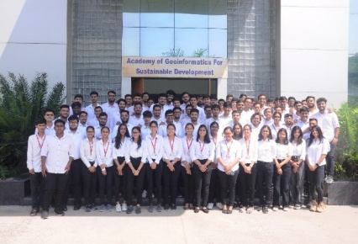
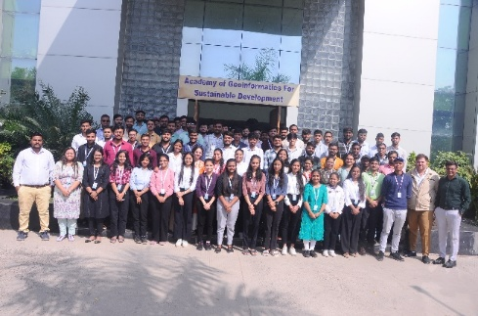
Standardization Directorate
BISAG-N has a dedicated directorate for ensuring continuously focus on innovation, standardization and institutionalization of solutions & service. The Standardization Directorate focuses on implementation of various national and international standards related to program solutions and data management. The directorate develops internal SOPs and policies for compliance to these standards and provides training for effective implementation. The directorate also liaison with the various departments and external agencies during internal and external audits. In addition, the directorate acts as member in standards committees of Bureau of Indian Standards (BIS) and other standard developing bodies for development of standards.

Goals of Standardization Directorate include:
- To proactively implement product and process improvements initiatives using various national & international standards and best practices. This includes ensuring quality and reliability of geo-spatial data, completeness, updation of metadata, functional performance and security reviews of applications, capacity building support to end-users for adoption of solutions and information security-oriented culture development
- To develop a culture of efficiently working as per standards while fostering innovation
- To perform reviews, gap analysis, training, documentation and standards implementation support activities
Administration Directorate
Administrative Directorate provides strategic and management support to various activities of BISAG-N. The directorate ensures infrastructure and facilities management in addition to providing services such as coordination during visits of various delegations, logistic support to BISAG-N staff during travel, accounting and finance, procurement, training, safety and security, legal compliance, maintenance, housekeeping, horticulture, construction and extension projects, campus monitoring, canteen management as well as celebrations and welfare activities. The directorate also ensure recruitment and human resource development as per the needs of various projects and directorates while upholding principles of equality, fairness and diversity in work force.
BISAG-N has adequate human resources, well trained for behavioral, functional and domain competencies, with clear roles and responsibilities in alignment with service delivery expectations. The staff well-being and motivation initiatives are ensured for maintaining a culture of shouldering responsibilities proactively and delivering high-performance utilizing multi-disciplinary knowledge.
Administration Directorate ensure strategic and compliance support to operations of the institute by managing human resources, facilities, expansion projects, finance and governance aspects. The directorate also coordinates with Council stakeholders and members of Governing and Executive committee as well as other high-level committees.
Defence Applications Directorate
This directorate develops space, geo-spatial, AI and other emerging technologies-based applications under the guidance of various agencies of the Ministry of Defence, Government of India. All the technologies used are developed inhouse of customized open source. Considering the strategic significance of these projects, dedicated team and premises are allocated for ensuring information security. Most of the critical activities and data management are performed directly at various defence establishments.

Besides the projects of various infrastructure and social welfare ministries and departments of central and state government, BISAG-N has a dedicated directorate for supporting defence and security departments for providing data products, decision support systems and services involving geo-spatial and various other emerging technologies. The projects are executed in high security dedicated laboratory for various units of army, navy and air-force for supporting strategic and operational aspects of the operations.
Through its innovative geospatial solutions and technological expertise, BISAG-N is playing a crucial role in enhancing the nation’s defence capabilities and ensuring long-term strategic autonomy. Due to nature of high secrecy of these strategic projects, they are not included in details in this compilation.
Research and Development
BISAG-N’s research and development group supports all other directorates for providing solutions related to new definitions and technology. The group develops innovative applications, features, tools and services utilizing technologies such as remote sensing, photogrammetry, artificial intelligence, machine learning, internet of things, computer vision, big data and quantum computing, which are later integrated in live projects.

BISAG-N has made significant progress for the development of Artificial Intelligence/ Machine Learning (AI/ML) applications. Algorithms and models have been developed which can be customized and used with training, validation and live data upon their data for accurate predictions and smarter results.

The applications developed by the R&D team include support for the pluggable APIs which can use the machine learning with minimal code reconfiguration. Various GIS applications are developed at BISAG-N. Utilizing spatial and non-spatial processing of Big Data and Web GIS architecture These applications support multi-terabyte datasets and large number of consumers. Big Data applications for visualization developed by the institute has enabled several projects to explore and analyse multiple large archives. Through continuous research and development, BISAG-N’s R&D capabilities are continuously enhanced. This allows to enhance users’ satisfaction, growth and success stories.
Cyber Security Cell
Cyber Cell reviews and update the threat landscape for the BISAG-N’s critical infrastructure on a regular basis in line with various vulnerabilities detected and published by reputed repositories. The cell verifies the applications using Vulnerability Assessment & Penetration Testing (VAPT) ensuring the compliance to Guidelines for Indian Government Websites (GIGW), Open Web Application Security Project (OWASP), SANS 25 etc. The cell also ensures implementation of good information security practices in line with ISO 27001 such as serious logs review, vulnerability analysis, exception reporting, maintenance of firewall and other network monitoring tools.

CANDIDATE’S DECLARATION
We declare that the 6th semester internship project report entitled “Change Detection Using Satellite Imagery” is our own work conducted under the supervision of the external guide Dr. Manoj Pandya from BISAG-N (Bhaskaracharya National Institute for Space Applications & Geo-informatics). We further declare that to the best of our knowledge, the report for this project does not contain any part of the work which has been submitted previously for such project either in this or any other institutions without proper citation.

Candidate 1’s Signature
Rajyavardhansingh Shekhawat
Student ID: 26BISAG0503

Candidate 2’s Signature
Vivek Rajak
Student ID: 26BISAG0502

Submitted To:
Gati Shakti Vishwavidyalaya - Vadodara

Acknowledgement

We are grateful to Shri T.P. Singh, Director General (BISAG-N), for giving us this opportunity to work the guidance of renowned people of the field of GIS-Based Portal, also providing us with the required resources in the company.
We would like to express our endless thanks to our external guide, Dr. Manoj Pandya, our coordinator Dr. Abdul Jhummarwala , our mentors Mr. Tarun Nagar & Mr. Mihir Mistry and to the Training Cell, Mr. Punit Lalwani & Mr. Siddharth Patel at Bhaskaracharya National Institute of Space Application and Geo-informatics, for their sincere and dedicated guidance throughout the project development.
Also, our hearty gratitude to our Head of Department, Dr. Vipul Kumar Mishra & Dr. Shweta Saharan for giving us encouragement and technical support on the project.

Rajyavardhansingh Shekhawat
Student ID: 26BISAG0503

Vivek Rajak
Student ID: 26BISAG0502

Abstract

This project explores the development or urbanization across a time period on the specific area of interest on earth using satellite images. It is a geospatial analysis project developed to identify and monitor changes occurring on the Earth's surface over time. The system uses Sentinel-2 satellite imagery and Google Earth Engine for data processing and analysis. A user-friendly web application is developed using Streamlit and Folium, enabling users to select an Area of Interest (AOI), compare satellite images from different years, and visualize detected changes interactively. The overlaying mask is created on the detected changes for a better visualization. The project helps in identifying construction, demolition, urban expansion, and other land-use changes efficiently. This solution can support urban planning, environmental monitoring, and decision-making by providing accurate and timely information about spatial changes. The results are displayed through interactive maps and statistical summaries, enabling users to easily interpret and assess spatial changes. Any region on our planet earth can be analyzed for change detection over any period of time with help of google earth engine.

CONTENTS

Chapter No. | Description | Page No.
— | List of Figures | i
— | List of Screenshots | ii
— | List of Tables | iii
— | List of Abbreviations | iv
— | List of Definitions | v
1 | Introduction | 1
1.1 | Project Details | 1
1.2 | Purpose | 2
1.3 | Scope | 2
1.4 | Objectives | 4
1.5 | Technology Stack Used | 5
1.6 | Literature Review | 6
1.6.1 | Landsat-Based Urban Change Detection | 6
1.6.2 | Sentinel-2 Based Land Cover Change Analysis | 6
1.6.3 | Google Earth Engine for Large-Scale Change Detection | 6
1.6.4 | Deep Learning-Based Change Detection | 7
1.6.5 | Web-Based Geospatial Monitoring Systems | 7
2 | Project Management | 8
2.1 | Feasibility Study | 8
2.1.1 | Technical Feasibility | 8
2.1.2 | Feasibility | 9
2.1.3 | Operational Feasibility | 9
2.1.4 | Implementation Feasibility | 10
2.2 | Project Planning | 10
2.3 | Project Scheduling | 11
3 | System Requirement Study | 21
3.1 | Existing System Overview | 21
3.2 | Limitations of the Existing System | 22
3.3 | User Characteristics | 22
3.3.1 | BISAG-N Space & GIS Analysts | 22
3.3.2 | Urban Planners & Environmental Monitors | 22
3.3.3 | System Administrators | 23
3.4 | Functional Requirements | 23
3.5 | Non-Functional Requirements | 25
3.6 | Hardware and Software Requirements | 26
3.6.1 | Server / Developer Machine | 26
3.6.2 | Software Prerequisites | 27
3.6.3 | Client Browser | 27
4 | System Analysis | 28
4.1 | Problem Definition | 28
4.2 | Analysis of Proposed Approach | 29
4.3 | Comparison of Approaches | 31
4.4 | Advantages of Proposed System | 34
5 | System Design | 35
5.1 | System Architecture Design | 35
5.2 | UML Diagrams | 36
5.2.1 | UML Component Architecture | 36
5.2.2 | Earth Engine Image Processing Pipeline Flow | 37
5.2.3 | Use Case Diagram | 38
5.3 | Database Design | 39
5.4 | GUI Design | 39
5.5 | Application Screenshots | 40
6 | Implementation Planning | 49
6.1 | Implementation Environment | 49
6.2 | Tools and Technologies Used | 50
6.2.1 | React + Vite (TypeScript) | 50
6.2.2 | Node.js & Express | 50
6.2.3 | Google Earth Engine Noje.js API | 50
6.2.4 | Tailwind CSS (v4) | 50
6.2.5 | Leaflet & Leaflet-Draw | 50
6.3 | Coding Standards Followed | 52
6.3.1 | TypeScript Strict Mode | 52
6.3.2 | Modular Component Design | 52
6.3.3 | Stateless API Routes | 52
6.3.4 | Error Handling and Graceful Degradation | 53
7 | Testing | 54
7.1 | Testing Plan | 54
7.2 | Types of Testing | 54
7.2.1 | Unit Testing — Spectral Index Math Logic (NDBI, NDVI) | 54
7.2.2 | Integration Testing — Node.js Express Server to GEE API Bridge | 55
7.2.3 | System Testing — Pipeline Analysis Verification | 55
7.2.4 | User Acceptance Testing (UAT) | 57
8 | Implications and Policy Recommendations | 59
8.1 | Practical Implications for Space/GIS Industry | 59
8.2 | Educational and Research Implications | 59
8.3 | Policy Recommendations for Urban Planning & Land Conservation | 61
9 | References | 62
10 | Appendix A — Project Code Architecture | 64
10.1 | GEE Image Processing Engine | 64
10.2 | Express API Route Handlers | 65
11 | Report Verification Procedure | 67

LIST OF FIGURES

Figure No. | Figure Description | Page No.
Fig. 1.1 | BISAG-N Organisational Overview | 2
Fig. 1.2 | Integration of drone images with satellite data for higher spatial accuracy. | 4
Fig. 1.3 | Landsat Based change detection | 6
Fig. 1.4 | Deep learning based change detection | 7
Fig. 4.1 | System Workflow | 29
Fig. 4.2 | Workflow Raw Imagery to map layer | 32
Fig. 4.3 | Georeferencing using QGIS Flowchart | 33
Fig. 4.4 | Flowchart of Change Detection Using GEE | 34
Fig. 5.1 | System Architecture Design | 35
Fig. 5.2 | UML Diagram | 36
Fig 5.3 | Earth Engine Image Processing Pipeline | 37
Fig. 5.4 | Use Case Diagram | 38

LIST OF SCREENSHOTS

Screenshot No. | Screenshot Description | Page No.
SS 1 | Earth3D Hero Page | 40
SS 2 | Interactive Analysis Screen | 40
SS 3 | AOI Sketching Tool | 41
SS 4 | Year Selection Dropdown | 41
SS 5 | True-colour Tile Fetching | 41
SS 6 | Swipe Splitter in Action | 42
SS 7 | Sensitivity Sliders Config | 42
SS 8 | Construction Detection Overlays | 43
SS 9 | Demolition Detection Overlays | 43
SS 10 | Real-Time Metrices Board | 43
SS 11 | Vector Data Export Trigger | 44
SS 12 | Earth Engine Connected | 44
SS 13 | Features | 45
SS 14 | Theme Selection | 45
SS 15 | Tuning Guide | 45
SS 16 | Earlier Approaches Results (a) - (f) | 46

LIST OF TABLES

Table No. | Table Description | Page No.
Table 1.1 | Technologies Used | 5
Table 2.1 | Project Milestone Timeline | 12
Table 2.2 | Week-by-week Activity Log | 13
Table 3.1 | Functional Dependencies | 23
Table 3.2 | Non-functional dependencies | 25
Table 4.1 | Comparison of Approaches | 31
Table 6.1 | Tools used with their roles | 51
Table 7.1 | Change Detection Test Results - Single-Index vs. 4-Index Ensemble Comparison | 56
Table 7.2 | Error Area Breakdown — Pipeline Anomaly Scenario | 57
Table 8.1 | Policy Recommendations | 61

LIST OF ABBREVIATIONS

Abbreviation | Full Form
AI | Artificial Intelligence
AOI | Area of Interest
API | Application Programming Interface
BISAG-N | Bhaskaracharya National Institute for Space Applications and Geo-informatics
CD | Change Detection
CRS | Coordinate Reference System
CSV | Comma-Separated Values
ESA | European Space Agency
GEE | Google Earth Engine
GeoTIFF | Geographic Tagged Image File Format
GIS | Geographic Information System
GSV | Gati Shakti Vishwavidyalaya
JSON | JavaScript Object Notation
LLM | Large Language Model
MeitY | Ministry of Electronics & Information Technology
RL | Reinforcement Learning
RS | Remote Sensing
TIFF | Tagged Image File Format
TOC | Table of Contents
UI | User Interface
UX | User Experience
List of Definitions

Term | Definition
Computer Vision | Computer Vision is a field of Artificial Intelligence that enables computers to interpret and analyze visual information from images and videos. It is widely used for object detection, image classification, and change detection applications.
Image Processing | Image processing refers to performing operations on digital images to improve their quality or extract useful information. It serves as the foundation for many computer vision tasks.
Feature Extraction | Feature extraction is the process of identifying important patterns, edges, textures, or shapes from an image. These features help in image analysis and object recognition.
Change Detection | Change detection is a technique used to identify differences between images captured at different times. It helps detect newly constructed or demolished structures.
JSON (JavaScript Object Notation) | A lightweight, human-readable data interchange format based on key-value pairs and arrays. Used in this project for game state serialisation, the LangGraph state object, and one of the two telemetry export formats.
CSV (Comma-Separated Values) | A plain-text tabular data format where values are separated by commas. One of the two session telemetry export formats, designed for direct import into spreadsheet analysis tools such as Excel or Google Sheets.
Google Gemini | Google's family of large language models, accessed via the Gemini API.
BISAG-N | Bhaskaracharya National Institute for Space Applications and Geo-informatics; an autonomous scientific society under MeitY, Government of India, headquartered in Gandhinagar, Gujarat. The organisation at which this internship was conducted.
Remote Sensing | Remote Sensing is the science of collecting information about the Earth's surface without direct physical contact. It relies on sensors mounted on satellites, aircraft, or drones to acquire data.
Satellite Imagery | Satellite imagery consists of images captured by Earth observation satellites. These images provide valuable information for mapping, monitoring, and environmental analysis.
Spatial Resolution | Spatial resolution refers to the size of the ground area represented by a single pixel in an image. Higher resolution provides more detailed observations.
Temporal Resolution | Temporal resolution indicates how frequently a satellite revisits and captures imagery of the same location. It is important for monitoring changes over time.
Google Earth Engine | Google Earth Engine (GEE) is a cloud-based geospatial analysis platform developed by Google. It provides access to large satellite datasets and powerful processing capabilities for Earth observation applications.
Image Collection | An image collection is a group of satellite images organized according to location, date, or sensor type. It allows efficient analysis of multi-temporal datasets.
Cloud Masking | Cloud masking is the process of identifying and removing cloud-covered pixels from satellite imagery. It improves the reliability of image analysis.
Earth Observation | Earth Observation refers to the collection and analysis of information about Earth's physical systems using remote sensing technologies.
Sentinel-2 Dataset | Sentinel-2 is a multispectral Earth observation satellite mission developed by the European Space Agency (ESA). It provides high-resolution imagery for monitoring vegetation, land use, and environmental changes.
Near Infrared | Near Infrared is a spectral region commonly used to analyze vegetation health. Healthy vegetation reflects a large amount of NIR radiation.
Short Wave Infrared | Short Wave Infrared is useful for detecting built-up areas, moisture content, and land-cover changes. It plays an important role in remote sensing analysis.
RGB Composite | An RGB composite is created by combining red, green, and blue spectral bands to generate a natural-looking image of the Earth's surface.
Geospatial Analysis | Geospatial Analysis is the process of examining and interpreting geographic data to identify patterns, relationships, and trends. It supports decision-making in planning and environmental monitoring.
Geographic Information System | GIS is a system used to capture, store, manage, analyze, and visualize geographic information. It helps users understand spatial relationships effectively.
GeoTIFF | GeoTIFF is a georeferenced image format that stores spatial information along with raster image data. It allows accurate positioning of imagery on maps.
Area of Interest | An Area of Interest is a user-defined geographic region selected for analysis. All processing and change detection operations are performed within this boundary.
Land Use Analysis | Land Use Analysis involves studying how land is utilized and how its characteristics change over time. It is essential for urban planning, environmental assessment, and resource management.
Land Use Land Cover | LULC represents the classification of land based on natural features and human activities. It helps understand the distribution of different surface types.
Construction Detection | Construction detection identifies newly developed buildings and infrastructure by comparing satellite images from different time periods.
Demolition Detection | Demolition detection identifies structures that have been removed or replaced over time. It is useful for monitoring urban redevelopment activities.
Spectral Indices | Spectral Indices are mathematical combinations of different spectral bands used to highlight specific surface characteristics. They simplify the analysis of vegetation, water bodies, and urban areas.
Normalized Difference Vegetation Index | NDVI is a vegetation index used to measure vegetation health and density. It is calculated using red and near-infrared spectral bands.
Normalized Difference Built-up Index | NDBI is used to identify urban and built-up areas from satellite imagery. It helps distinguish developed land from vegetation.
Normalized Difference Water Index | NDWI is a spectral index used to detect and monitor water bodies. It enhances water features while suppressing other land-cover types.
GeoTIFF | GeoTIFF is a raster image format that stores geographic information along with image data. It allows satellite images to be accurately positioned on the Earth's surface.
Raster Data | Raster data consists of a grid of pixels where each pixel contains a value representing a geographic attribute. Most satellite images are stored in raster format.
Pixel | A pixel is the smallest unit of a digital image. In satellite imagery, each pixel represents a specific ground area and contains information about surface characteristics.
Spectral Resolution | Spectral resolution refers to a sensor's ability to distinguish between different wavelengths of the electromagnetic spectrum. Higher spectral resolution improves feature identification.
Urban Expansion | Urban expansion refers to the growth of cities and built-up areas into surrounding regions. Satellite imagery is commonly used to monitor and analyze this growth.
Visualization | Visualization is the graphical representation of spatial data and analysis results. Interactive maps and dashboards help users understand detected changes effectively.
Streamlit | Streamlit is an open-source Python framework used for developing interactive web applications. It enables rapid deployment of data science and geospatial projects.
Folium | Folium is a Python library used to create interactive maps. It allows visualization of geographic data directly within web applications.
User Interface (UI) | The User Interface is the visual component through which users interact with the application. A well-designed UI improves usability and user experience.
Latitude | Latitude is a geographic coordinate that specifies the north-south position of a location on the Earth's surface. It is measured in degrees.
Longitude | Longitude is a geographic coordinate that specifies the east-west position of a location. It is also measured in degrees.
Coordinate Reference System | A Coordinate Reference System defines how geographic locations are represented on maps. It ensures accurate positioning and analysis of spatial data.
Digital Image | A digital image is a two-dimensional representation of visual information composed of individual pixels. Each pixel stores intensity or color information that collectively forms the complete image. Digital images are the primary source of data for image processing and analysis.
Image Registration | Image registration is the process of aligning two or more images of the same area captured at different times or by different sensors. Proper alignment ensures that corresponding pixels represent the same ground location. It is a critical preprocessing step in change detection.
Image Segmentation | Image segmentation is the technique of dividing an image into meaningful regions based on similar characteristics such as color, texture, or intensity. It simplifies image analysis by isolating objects or areas of interest. Segmentation is widely used in object extraction and land-cover mapping.
Multispectral Imaging | Multispectral imaging captures image data at multiple wavelengths across the electromagnetic spectrum. Different surface features reflect energy differently in each band, enabling better identification of vegetation, water bodies, and built-up areas. It is a key feature of Sentinel-2 imagery.
Urban Monitoring | Urban monitoring involves observing and analyzing changes occurring in cities and built-up areas over time. Satellite imagery provides an efficient method for tracking urban growth, infrastructure development, and land-use changes. It supports planning and sustainable development initiatives.
Feature Matching | Feature matching is the process of identifying corresponding features between multiple images. It is commonly used for image alignment, object tracking, and change detection applications. Accurate feature matching improves analysis reliability.
Building Extraction | Building extraction refers to the identification and delineation of buildings from satellite imagery. It helps in urban planning, infrastructure assessment, and change monitoring. Automated extraction techniques reduce the need for manual mapping.
Land Transformation | Land transformation refers to changes in land characteristics caused by natural processes or human activities. Examples include urbanization, deforestation, agricultural expansion, and infrastructure development. Monitoring these transformations supports effective resource management.
Geospatial data | Geospatial data contains information related to the geographic location and attributes of objects on the Earth's surface. It combines spatial coordinates with descriptive information for analysis and visualization. Such data forms the foundation of GIS applications.
Pixel-Based Analysis | Pixel-based analysis evaluates changes by comparing the values of individual pixels between images acquired at different times. It is one of the most common approaches used in change detection. The accuracy of results depends on image quality and proper alignment.
Object-Based Analysis | Object-based analysis groups neighboring pixels into meaningful objects before performing classification or change detection. This approach considers shape, size, texture, and contextual information. It often produces more accurate results than pixel-based methods.
Georeferencing | Georeferencing is the process of assigning real-world geographic coordinates to an image or map. It ensures that spatial data aligns correctly with other geographic datasets. Accurate georeferencing is essential for reliable change detection.
Ground Truth Data | Ground truth data consists of information collected directly from the Earth's surface to verify satellite-based observations. It serves as a reference for evaluating the accuracy of classification and change detection results. Ground truth data improves the reliability of remote sensing studies.
Data Accuracy | Data accuracy describes how closely observed values represent actual ground conditions. In satellite image analysis, high accuracy is essential for producing reliable results. Various validation techniques are used to assess data quality.
Monitoring and Assessment | Monitoring and assessment involve the continuous observation and evaluation of environmental or infrastructural conditions. These activities support informed decision-making and policy development. Satellite imagery enables efficient monitoring over large geographic areas.
Sustainable Development | Sustainable development refers to meeting present needs without compromising the ability of future generations to meet their own needs. Geospatial technologies assist in achieving sustainable development by supporting resource management and environmental conservation.
Decision Support System | A Decision Support System (DSS) is a computer-based tool that assists users in making informed decisions by analyzing and presenting relevant information. Geospatial DSS applications often integrate satellite imagery, GIS, and change detection techniques.
Spatial Database | A spatial database is a database designed to store, manage, and retrieve geographic information. It supports spatial queries and analysis operations. Spatial databases are commonly used in GIS and remote sensing applications.
Change Vector Analysis | Change Vector Analysis is a technique used to measure the magnitude and direction of change between two satellite images. It analyzes spectral differences across multiple bands simultaneously. CVA is commonly used in land-cover and urban change studies.
Radiometric Correction | Radiometric correction is the process of adjusting pixel values to reduce the effects of atmospheric conditions, sensor noise, and illumination differences. It ensures consistency between images acquired at different times. This improves the reliability of change detection results.
Atmospheric Correction | Atmospheric correction removes the influence of atmospheric particles, water vapor, and aerosols from satellite imagery. It converts raw satellite measurements into more accurate surface reflectance values. This step is essential for multi-temporal image comparison.
Built-Up Area | A built-up area consists of human-made structures such as buildings, roads, and other infrastructure. Monitoring built-up areas helps assess urban growth.
Land Degradation | Land degradation refers to the deterioration of land quality caused by natural processes or human activities. It may include soil erosion, deforestation, or urban encroachment. Remote sensing helps monitor such changes over time.
Geospatial Intelligence | Geospatial Intelligence is the collection and analysis of geographic information to support planning and decision-making. It combines satellite imagery, GIS, and spatial analysis techniques. It is widely used in environmental and infrastructure monitoring.
Time Series Analysis | Time series analysis examines data collected at multiple time intervals to identify patterns and trends. In remote sensing, it helps understand long-term environmental and urban changes. It is particularly useful for monitoring seasonal variations.
Ground Sampling Distance (GSD) | Ground Sampling Distance represents the distance between the centers of adjacent pixels on the ground. It determines the level of detail visible in an image. Smaller GSD values indicate higher image resolution.
Change Map | A change map is a visual representation of detected changes between two or more satellite images. It highlights areas where significant transformations have occurred. Change maps help users quickly identify regions of interest.
Land Monitoring | Land monitoring is the continuous observation of changes occurring on the Earth's surface. It supports environmental protection, urban planning, and natural resource management. Satellite imagery enables large-scale monitoring efficiently.
Image Mosaic | An image mosaic is created by combining multiple satellite images into a single seamless image. This technique is useful for covering large geographic regions. Mosaics provide complete spatial coverage for analysis.
Image Enhancement | Image enhancement is the process of improving the visual quality of satellite images to make important features more distinguishable. Techniques such as contrast stretching and filtering are commonly used. Enhanced images facilitate more accurate interpretation and analysis.
Noise Reduction | Noise reduction is the process of removing unwanted distortions, random variations, or irrelevant information from digital images. In satellite imagery, noise may be caused by sensor limitations, atmospheric conditions, or transmission errors. Noise reduction techniques improve image quality and enhance the accuracy of image analysis and change detection.
Edge Detection | Edge detection is a technique used to identify boundaries between different objects or regions in an image. It highlights sudden changes in pixel intensity and assists in object recognition. Edge detection is widely used in image processing and computer vision applications.
Precision | Precision measures the proportion of correctly identified positive observations among all predicted positive observations. A high precision value indicates a low rate of false detections. It is commonly used to evaluate change detection systems.
Recall | Recall measures the proportion of actual positive observations correctly identified by a model. It reflects the ability of a system to detect all relevant changes. Higher recall indicates fewer missed detections.
F1 Score | The F1 Score is a performance metric that combines precision and recall into a single value. It provides a balanced measure of classification effectiveness. Higher F1 scores indicate better overall performance.
Decision Making | Decision making is the process of selecting appropriate actions based on available information and analysis. Geospatial technologies provide valuable insights that support evidence-based decision making in planning and resource management.
Geospatial Workflow | A geospatial workflow is a sequence of processes used to collect, process, analyze, and visualize geographic data. It ensures systematic handling of spatial information. Well-designed workflows improve efficiency and reproducibility.

1. Introduction

1.1 Project Details

The need for efficient methods to detect and assess the changes over time has increased significantly with the rapid growth of urbanization, infrastructure development and environmental changes. Traditional field surveys are too much time consuming, costlier, needs human on field and limited in coverage, making it difficult to analyze. A remote sensing technique used to detect changes in an image of a geographical area taken at different times of year is called Change Detection. Using multi-temporal satellite imagery, it is possible to identify new buildings, buildings that have been demolished, land changes and any other changes that may be of interest.

This project "Change Detection Using Satellite images" is successfully completed project during internship at BISAG-N (Bhaskaracharya National Institute for Space Applications and Geo-informatics). Sentinel-2 satellite data and Google earth engine (GEE) are employed in the project for large scale geospatial data processing and analysis. An interactive web-based application is created in Streamlit and Folium to visualize and analyze changes. Users can pick an Area of Interest (AOI), select the years to compare the images of that AOI, and determine changes that have taken place within the chosen region in the selected years. The outcome is visualised with interactive maps and visually appealing presentation, to facilitate user understanding of the changes. It illustrates the capability of using remote sensing technologies together with the use of modern web-based tools to develop effective solutions for geospatial monitoring and analysis.

The Project has been developed during an eight-week Internship program at Rajyavardhansingh Shekhawat and Vivek Rajak, at Bhaskaracharya National Institute for Space Applications and Geo-informatics (BISAG-N), Gandhinagar, under the auspices of the Ministry of Electronics and Information Technology, Government of India.
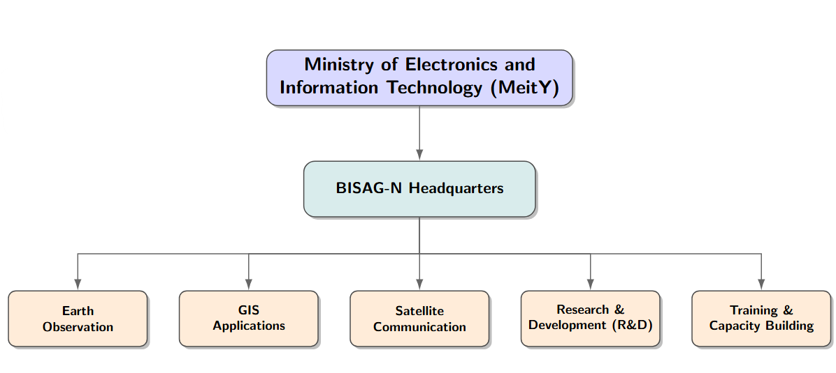
Figure 1.1: BISAG-N Organisational Overview

1.2 Purpose

This project aims to create an efficient and user-friendly system to detect changes over any part of the Earth's surface from satellite images. Monitoring changes such as new construction, demolition of old buildings , urban expansion, urbanization, growth in vegetation and land use changes. The conventional methods for tracking these changes are time-consuming and labor-intensive, and can be complemented by automated analysis from satellites.

The project's other goal is to leverage the power of the modern geospatial tools (Google Earth Engine and Sentinel-2 satellite data). Cloud-based processing enables the system to process satellite data efficiently, and deliver high-quality information about changes over time. This minimises the processing load and enhances the user experience.

The project provides an interactive user interface platform through which they can easily select an Area of Interest (AOI), compare satellite images from different years tovisualize detected changes. By combining the capabilities of Streamlit with Folium, the results are presented in an intuitive and easy-to-understand manner, allowing for geospatial analysis to be introduced even to users with limited technical skills. Apart from that, the system can be adapted to different real world applications, decision making and can enable effective use of geospatial technologies for sustainable development.

1.3 Scope
The aim of this project is to design and implement an online change detection system to process satellite imagery taken at various dates and detect substantial changes that occur within the Earth's surface. The system targets the identification of new buildings, construction or demolition, urban expansion, and other land uses changes in a defined Area of Interest (AOI). The project will expand to:
- Projects that merge Deep Learning Models.Projects that combine Deep Learning Models. The advanced deep learning models can be integrated to enhance accuracy of change detection and building identification.
- Real-Time Change Monitoring The system can be expanded to monitor almost in real-time, with images from the satellites updated over time.
- Support for multiple satellite datasets. Other data, including Landsat, PlanetScope, and Sentinel-1 data, can be added for greater analysis.
- Automated Building Extraction Manual interpretation efforts can be reduced by implementing automated extraction and classification of buildings.
- Mobile Application Development The mobile version of the application can be created to make the application more accessible and easily used in the field.
- AI-Based Change Classification Changes can be automatically classified into categories, such as construction, demolition, vegetation loss and water body changes, using Artificial Intelligence techniques.
- Report Generation Module An automatic report generation feature can be integrated, which provides instant summaries and analysis report.
- Disaster Impact Assessment The system can be modified to evaluate damages during floods, earthquakes, landslides and other natural calamities.
- Adopting GIS platforms for integration. The integration with GIS software can improve spatial analysis and data management features. High-resolution satellite imagery support.
- Future versions will be able to use higher resolution imagery, which will enhance the capability to detect smaller changes and structures.
- Historical Change Analysis The application can be further extended to allow for analysing of changes over long time spans (several years) and report on the trends.
- Decision Support System The system can be coupled with planning and management tools that can aid government agencies and urban planners in decision-making.
- Urban Growth Prediction Predictive models can be created to predict future urban growth using past satellite observations.
- Deforestation Monitoring The system can be further enhanced for tracking forest loss, afforestation and environmental degradation.
- Agricultural Land Monitoring Future versions can monitor the condition of the crop, the seasons and how land is being used for agriculture.
- Infrastructure Development Tracking Satellite imagery can be used to automatically monitor roads, bridges, railways and development projects.
- Drone Data Integration UAV/drone imagery could be used alongside to achieve more detailed analysis and higher spatial resolution..
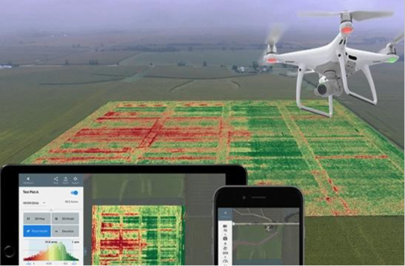
Figure 1.2: Integration of UAV/drone imagery with satellite data for higher spatial accuracy.

1.4 Objectives
We were aiming for these: To create a satellite-based image change detection Web system.
1. To access and manipulate Sentinel-2 satellite data in Google Earth Engine.
2. To give users the option to choose an Area of Interest (AOI) to do custom analysis on this.
3 .To 'date' satellite images and recognize change.
4. To find new buildings and building demolition sites in the specified area.
5. To use remote sensing technology to track urban growth and land-use change.
6. To create an interactive visualization platform with Streamlit and Folium.
7. Present information and trends from the changes detected on maps and statistical summaries to facilitate interpretation.
8. To aid urban planning, infrastructure development and environmental monitoring.

1.5 Technology Stack Used
The table below enlists the majorly used technologies in this project with their purposes.

Technology | Purpose
Python | Application Development
Google Earth Engine | Satellite Data Processing
Sentinel-2 | Satellite Imagery Source
Streamlit | Web Application Development
Folium | Interactive Map Visualization
Geemap | GEE Integration with Python
GIS | Spatial Analysis
Remote Sensing | Change Detection Analysis
Cloud Computing | Large Scale Processing
JSON/GeoTIFF | Data Export
Table 1.1: Technologies Used

The development of the Change Detection Using Satellite Images system required bringing together a number of technologies that enable the efficient processing, analysis and visualization of the data. The primary coding language used was Python because of its rich support for geospatial and data science applications. Cloud-based platform for access and processing of Sentinel-2 satellite imagery was offered by Google Earth Engine (GEE). Streamlit was used to create an interactive web application, and Folium and Geemap were used to visualize and represent the geospatial data. Furthermore, the concepts of Geographic Information System (GIS) and Remote Sensing techniques were used to analyse the spatial changes and to provide results of change detection.

1.6 Literature Review

1.6.1 Landsat-Based Urban Change Detection
There have been several researchers who have used Landsat satellite imagery for long-term monitoring of urban growth and land-use changes. The image differencing and classification techniques were used in these studies to identify new urban development areas. Historical Landsat data has become one of the most widely used data set for change detection application due to its availability.
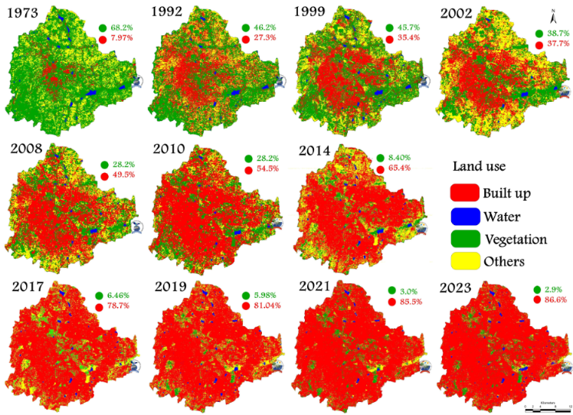
Figure 1.3: Landsat based change detection
1.6.2 Sentinel-2 Based Land Cover Change Analysis
Sentinel satellites enabled researchers to obtain higher spatial and temporal resolution data. Sentinel-2 data have been employed in several studies for change detection of land use, urban growth and infrastructure. A major improvement in accuracy of change detection results has been achieved thanks to the multispectral features of Sentinel-2.

1.6.3 Google Earth Engine for Large-Scale Change Detection
In recent years, the interest has been directed towards using GEE to process and analyze huge satellite data sets. The cloud-based platform facilitates efficient processing of multi-temporal imagery and decreases computer requirements. It has been proven in various studies to be effective in environmental monitoring, disaster assessment and urban development analysis.

1.6.4 Deep Learning-Based Change Detection
Recent research has investigated the possibility of using Convolutional Neural Networks (CNNs) and other deep learning models in the field of automatic change detection. These methods can be trained directly from satellite images to capture intricate spatial features, and have demonstrated improved accuracy rather than conventional methods. Deep learning has been emerging as a fast developing field in remote sensing research.

1.6.5 Web-Based Geospatial Monitoring Systems
The creation of web-based geospatial monitoring systems was also promoted.Web-based geospatial monitoring systems were also encouraged. Web-based platforms that integrate satellite data, GIS technologies and interactive visualization are being developed. These systems enable assessments of spatial change using web-based applications, without the need of special software. These types of sites have made it easier for non-technical users.
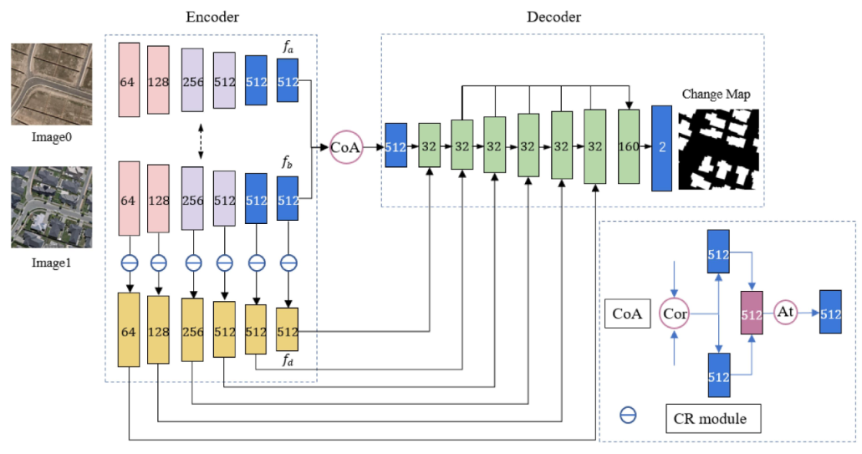
Figure 1.4: Deep Learning Based Change Detection

2. Project Management

We performed a feasibility study prior to coding, delivered weekly and followed a realistic schedule for an 8 week internship. All that is documented in this chapter.

2.1 Feasibility Study

Comprehensive feasibility study is performed before the development to examine the practicality, viability and operation limitations of the proposed system. This provides an optimal match between resource spending and technical capacity and institutional need. The analysis of the Satellite Change Detection Platform feasibility has been conducted based on four important aspects: Technical, Economic, Operational and Schedule .Feasibility

2.1.1 Technical Feasibility

Technical feasibility assesses the potential for creating the platform using the software and hardware tools, and whether the team has the technical expertise to do so.

Serverless Cloud Processing: Multispectral satellite rasters are highly computation-intensive. The project is therefore quite feasible since the raw data are huge and need to be downloaded and processed on the ground in standard remote sensing workflows. GEE performs cloud-masking, median compositing and spectral index math using Google's distributed high performance servers.

Single Language Stack: The front-end and back-end codebase are both written in JavaScript using React (Vite) for the front-end and Node.js (Express) for the back-end. The @google/earthengine library is used to connect the backend with GEE.

Packaging and Distribution: Standalone desktop packaging is made technically feasible with the pkg tool, which packages the Node.js runtime, service account keys and the compiled React code into a single executable .exe file that does not contain any dependencies. Portability is further guaranteed on Linux/Windows servers using Docker containers.

2.1.2 Time Feasibility

The time limit for the project was 8 weeks. Rapid Prototyping: An on-premise image cataloging, storage and preprocessing engine would take several months to develop. The direct access to the Copernicus Sentinel-2 Level-2A (Bottom-of-Atmosphere) collection from the data catalog in GEE has saved several months of infrastructure set-up. They also separated the frontend UI (Leaflet map coordinates, controls) from the backend API (GEE calculations) which meant they could work concurrently, and the 8-week period turned out to be plenty of time to not only get the system fully tested and ready for production but even more.

2.1.3 Operational Feasibility

Operational feasibility analyzes the ability of the system to meet the everyday tasks and capabilities of the BISAG-N target users. User Accessibility: Remote sensing software (e.g., QGIS, ArcGIS, or ENVI) is difficult to learn, and users must perform a number of preprocessing steps manually (atmospheric correction, index calculation, masking, filtering). GeoChronos makes this easy with an interactive web dashboard.

Interactive Auditing: An interactive spatial swipe tool is included so GIS analysts can conduct the visual auditing of the baseline and target years side by side, and verify the validity of the computed construction or demolition metrics instantly.

Export Workflows: Vectors are exported as GeoJSON and rasters are exported as GeoTIFF, which ensures the outputs will fit into existing GIS pipelines. Lastly, the platform is built with the intent of being consistent with the current enterprise architecture of BISAG-N, with no proprietary or closed-source structure of data being generated. The data is directly downloaded from the platform in standard GIS formats: vector boundaries as GeoJSON, and classification rasters as GeoTIFF. This allows for easy importation of these outputs directly into local databases, national mapping pipelines or QGIS projects for further overlays. This output compatibility means, that GeoChronos does not create an isolated data silo, but rather it's a fast-preprocessing tool to build on the existing operational constellation of the institute.

2.1.4 Implementation Feasibility
Implementation feasibility involves technical aspects of deployment and maintenance of software in the institute's network.
- Zero-Dependency local Executable: Workstations may not have software runtimes because of limited administrative access. Using pkg, the React frontend and Node backend can be compiled into a single standalone binary (TerraWatch.exe), so that analysts can double click it and run the system without node/npm setup. However, user-interactive Google logins are hard to manage on a restricted network.
- The Node backend automatically uses GEE Service Account credentials (ornate-serenity-499107-v4-123736109b8e.json) when it is started to silently authenticate using the private keys, while maintaining configuration-free GEE access.
- Enterprise Containerization: When deploying to servers, the multi-stage Docker build packages the React static bundle and the Node.js Express server in a lightweight Alpine container. Host OS dependency issues have been removed, it's currently running on port 8000 through Docker Compose.
- Modularity & Maintenance - The client-server architecture makes it possible to break up UI changes from changes in the backend GEE API. The application was designed using standard web protocols (HTTP, REST, JSON), making it easily maintainable and upgradeable by future BISAG-N developers in the future without specialized vendor tools.

2.2 Project Planning
We worked on the project on a fast, agile time frame. There were clear goals and deliverables for each day. Every week there was a clear target to achieve. We didn't do formal sprint planning or story point estimation as the team was two people in the same physical space and would have wasted a lot of time with a daily standup. Instead, we have a shared list of tasks and end-of-day code review to sync up progress.
We adopted a light weight Agile cadence to run the project. There was a clear task to be accomplished on a daily basis, as well as a weekly task. No formal sprint planning or story point estimation – the team was 2 people and in the same room so daily stand up calls would not have been necessary. Rather, we employed a common task list and code review at the end of the day to keep the work in sync.
The entire project timeline was divided into four different phases over an 8 week period:
Phase 1 (Weeks 1–2): Research, tool selection, and laying the groundwork for the frontend environment – the React (Vite) front-end, rendering the map canvas with Leaflet, and investigating the Google Earth Engine (GEE) Node.js authentication protocols.
During Phase 2 (Weeks 3-4), the core GIS integration was carried out, including the embedding of the interactive Leaflet-Draw tools to collect Area of Interest (AOI) coordinate bounds and the development of the GEE cloud-masking pipeline and the 4-index math model (Normal Difference Vegetation Index [NDVI], Normal Difference Building Index [NDBI], Multi-Temporal Normal Difference Water Index [MNDWI], and the Building Shadow Index [BSI]).
Phase 3 (Weeks 5-6): Backend reconstruction, noise filtering and UI polishing: Coding GEE focal median filters, metrics engine (Accuracy/F1), vectorization pipelines. This also involved the transition of the architecture from Python (FastAPI) to Node.js (Express), new standalone binary packaging (pkg) and initial containerization (Docker) and a new background animation with the rising bubble.
Phase 4 (Weeks 7-8) focused on end-to-end testing (Unit, Integration, System, and UAT), deployment testing with containers on Linux machines, and documentation transfer of the project.
Risk management was non-formal but planned. In the early stages we highlighted three issues that might be a problem in the project:
1. The Google Earth Engine API is limited by the number of coordinates within the boundary.
2. Cloud cover constraints for composite generation in Sentinel-2.
3. Packaging static assets to a standalone binary.
We dealt with all three early in the project, just in case one of them is a dead end and we can still turn a corner. None of them were.

2.3 Project Scheduling
Table 2.1 provides the milestone timeline for the project. Table 2.2 gives the full week-by-week activity log.

Week | Milestone | Key Deliverable
Week 1 (18–24 May) | Research & Fundamentals | Comparative study report on OpenCD (Open Change Detection) Deep Learning models (such as SiameseNet, ChangeFormer, BIT)
Week 2 (25–31 May) | Architecture & Environment | Study of Sentinel-2 spectral characteristics (10m vs. 20m bands), frontend workspace setup, Leaflet integration, and interactive map frame.
Week 3 (1–7 June) | GIS Drawing & Broker Setup | Leaflet-Draw tools capturing Area of Interest (AOI) coordinates, FastAPI broker server setup, and Service Account key credential validation tests.
Week 4 (8–14 June) | GEE Processing Engine | Sentinel-2 cloud masking (SCL + QA60 bitmasking) and GEE mathematical models for NDVI, NDBI, MNDWI, and BSI composites.
Week 5 (15–21 June) | Analytics & Exporters | GEE focal median noise filter, confusion matrix metrics calculations (Accuracy, F1-Score), and vector GeoJSON/raster GeoTIFF export pipelines.
Week 6 (22–28 June) | Architecture Pivot & Polish | Express GEE Node.js server rewrite, rising bubble background animation, standalone Windows binary compilation , and Docker environment.
Week 7 (29 June – 5 July) | Quality Assurance | Express-to-GEE integration tests, spectral math unit tests, Docker container performance validation, and UAT feedback trials with GIS analysts.
Week 8 (6–13 July) | Project Handover | Final project documentation, user handbooks, developer installation guides, and software deployment demonstration at BISAG-N.
Table 2.1: Project Milestone Timeline
Date | Rajyavardhansingh Shekhawat (26BISAG0503) | Vivek Rajak  (26BISAG0489)
Week 1 — 18 May to 24 May 2026
18/05/2026 | Initialized workspace environment; studied Sentinel-2 and Landsat optical band structures (Red, Green, Blue, NIR, SWIR) and their spatial resolutions. | Initialized the project repository; researched OpenCD (Open Change Detection) framework and cataloged deep learning change detection architectures.
19/05/2026 | Researched spectral signatures of vegetation, bare soil, and concrete surfaces across NIR and SWIR bands to define manual threshold ranges. | Studied ChangeFormer and Bitemporal Image Transformer (BIT) structures; reviewed attention-based feature fusion mechanisms.
20/05/2026 | Studied Google Earth Engine (GEE) Python API documentation; researched SCL (Scene Classification Layer) and QA60 cloud masking techniques. | Analyzed pre-trained weight architectures for ChangeFormer on LEVIR-CD and WHU-CD datasets; assessed data input formatting.
21/05/2026 | Designed wireframes for the bitemporal swipe dashboard UI; documented requirements for interactive Leaflet map panels. | Set up local PyTorch environment with OpenCD dependencies; tested basic inference scripts on sample bitemporal satellite image tiles.
22/05/2026 | Reviewed spatial resolution parameters and mapped optical bands requirements for ensemble calculations. | Conducted execution latency and memory utilization benchmarks for BIT and ChangeFormer; identified local hardware performance constraints.
23–24/05 | Holiday | Holiday
Week 2 — 25 May to 31 May 2026
25/05/2026 | Researched state management strategies for handling complex UI selections (years, indices, threshold values) in React. | Analyzed the mathematical formulations of remote sensing indices: NDBI (Built-Up), NDVI (Vegetation), MNDWI (Water), and BSI (Bare Soil).
26/05/2026 | Configured React frontend project scaffold using Vite, TypeScript, and TailwindCSS configuration files. | Conducted code review of the legacy Python Streamlit prototype (2.py); extracted logic for GEE map tiles and calculations.
27/05/2026 | Developed the global styling framework and configured CSS variables for a modern dark-themed glassmorphism interface. | Formulated cloud-masking algorithms for Sentinel-2 using QA60 bitmask flags; verified results in GEE Code Editor.
28/05/2026 | Developed responsive layout sidebars and parameter input sliders for threshold settings. | Wrote seasonal median composite scripts in GEE; compared image quality using different month intervals.
29/05/2026 | Built components for year selection dropdowns and coordinate input panels; tested component responsiveness. | Designed the 4-index ensemble voting classifier framework to evaluate construction and demolition change categories.
30/05/2026 | Worked on better accuracy. | Labels were defined more.
31/05/2026 | Holiday | Holiday
Week 3 — 1 June to 7 June 2026
01/06/2026 | Integrated Leaflet library (react-leaflet) in the React app; configured base map styling and layers. | Set up the initial Python FastAPI backend wrapper project; configured server environment and router files.
02/06/2026 | Integrated leaflet-draw tools to enable users to draw custom Area of Interest (AOI) polygons directly on the map. | Configured GEE Python authentication using the service account credential file.
03/06/2026 | Coded frontend GeoJSON serialization logic to send user-drawn polygon coordinates to the API backend. | Coded backend parser endpoint to accept GeoJSON polygon coordinates and instantiate GEE geometry instances.
04/06/2026 | Built the side-by-side bitemporal map layout; integrated a draggable swipe slider for interactive visual comparison. | Implemented API endpoint /api / tiles returning bitemporal satellite layer tiles for the selected years.
05/06/2026 | Developed dynamic frontend validation rules preventing invalid coordinates or mismatched target dates. | Configured FastAPI middleware for CORS handling to connect securely with the React frontend server.
06/06/2026 | Implemented CSV and JSON data export with session metadata. | Implemented export pipeline; added filename timestamping and data validation.
07/06/2026 | Holiday | Holiday
Week 4 — 8 June to 14 June 2026
08/06/2026 | Implemented visual loading indicators and progress states on the map for GEE backend requests. | Implemented GEE Sentinel-2 cloud and shadow masking using QA60 and SCL bands in the composite pipeline.
09/06/2026 | Integrated coordinate display tooltips showing real-time latitude/longitude under the map cursor. | Coded the GEE mathematical implementations for NDVI and NDBI calculations on target composites.
10/06/2026 | Refactored the dashboard layout to display dynamic analysis summary cards. | Coded the GEE mathematical calculations for MNDWI and BSI indices.
11/06/2026 | Built individual spectral band overlay toggle buttons on the map toolbar. | Implemented the Ensemble Voting logic, combining individual index change detections and applying NDVI masks to reduce false positives.
12/06/2026 | Handled map layer synchronization, ensuring swipe maps scroll, zoom, and pan in unison. | Investigated and resolved projection mismatch errors (CRS) during Sentinel-2 imagery fetches in GEE.
13/06/2026 | Holiday | Holiday
14/06/2026 | Holiday | Holiday
Week 5 — 15 June to 21 June 2026
15/06/2026 | Developed an interactive map legend mapping colors to change categories  ( Construction / Demolition ). | Programmed GEE focal median filtering (focalMedian) to eliminate salt-and-pepper noise from change maps.
16/06/2026 | Implemented statistics display components to visualize computed hectares of land cover change. | Coded GEE spatial statistics module calculating overlap accuracy metrics (TP, TN, FP, FN, and F1-score).
17/06/2026 | Programmed charts using Recharts to display index value distributions within the selected AOI. | Implemented GEE vectorization logic (reduceToVectors) to extract polygon borders of detected changes.
18/06/2026 | Created UI download buttons for requesting GeoJSON vector and GeoTIFF raster file outputs. | Implemented API endpoint / api / download - geotiff proxying GEE download URLs for local storage.
19/06/2026 | Verified GeoJSON vector overlays rendering on top of the Leaflet map container. | Optimized GEE composite calls to minimize API overhead and improve tiles response time.
20/06/2026 | Handled errors during verification. | Researched about GEE APIs.
21/06/2026 | Holiday | Holiday
Week 6— 22 June to 28 June 2026
22/06/2026 | Created ParticleBackground.tsx to render upward-rising bubbles using CSS custom variables to feed randomized animations. | Initiated backend migration to Node.js; configured Express backend repository structure and package.json  dependencies.
23/06/2026 | Configured scale-frames and fade-frames keyframes in CSS for smooth bubble movement and glowing effects. | Integrated @google/earthengine library in Node.js; implemented service account authentication via JSON key.
24/06/2026 | Re-routed the frontend API client functions to query the new Node.js Express server on port 8000. | Ported the cloud-masking and seasonal composite GEE scripts from Python syntax to JavaScript GEE API.
25/06/2026 | Configured Express to serve the production-built React frontend assets (dist) statically. | Ported the /api/analyze endpoint containing index calculation, focal median filters, and vectorization.
26/06/2026 | Created build_node_exe.js compiler script automating frontend build, file copying, and pkg compilation. | Configured pkg packaging configuration inside package.json to bundle server scripts, static assets, and GEE key files.
27–28/06 | Holiday | Holiday
Week 7 — 29 June to 5 July 2026
29/06/2026 | Wrote test suites validating UI input parameters (date bounds, coordinate ranges, threshold limits). | Configured multi-stage Docker builds inside Dockerfile and docker-compose.yml for Node.js Express.
30/06/2026 | Tested UI swipe-map features across Chrome, Edge, and Firefox browsers to verify compatibility. | Conducted API load tests on GEE calculations under concurrent requests to monitor server memory usage.
01/07/2026 | Executed and validated compiled TerraWatch.exe on different Windows configurations. | Resolved relative file path issues inside the compiled executable package (pkg) for GEE credentials.
02/07/2026 | Audited styling configurations, ensuring glassmorphic overlays and backdrop blurs perform smoothly on low-spec client machines. | Debugged asset compression inside Docker container, reducing image sizes.
03/07/2026 | Logged feedback from trial walkthroughs; adjusted default index parameters for optimal construction detection. | Optimized Express gzip response settings to reduce payload delivery latency for map tiles.
04/07/2026 | Discussed the progress till now with mentor sir.
05/07/2026 | Holiday | Holiday
Week 8 — 6 July to 12 July 2026
06/07/2026 | Written the React frontend user manual detailing parameter setup and map interactions. | Documented Node.js API endpoints and rebuild procedures for compiling standalone executables.
07/07/2026 | Prepared slides for the final internship presentation; drafted the software architecture schemas. | Cleaned up the repository, deleting legacy Python backend code, unused scripts, and configuration files.
08/07/2026 | Documented Leaflet drawing integrations and dynamic UI components in the report. | Authored deployment manuals for Docker configurations and environment setups.
09/07/2026 | Drafted final report sections detailing change detection metrics and validation analysis. | Compiled backend report sections explaining composite generation algorithms and GEE optimizations.
10/07/2026 | Finalized project presentation and submitted the complete internship report. | Completed repository handover and archived project source code.
11–12/07 | Holiday | Holiday

Table 2.2: Week-by-Week Internship Activity Log

3. System Requirement Study

This chapter specifies the technical requirements, dependency mapping, hardware/software infrastructure requirement, and the functional and non-functional requirements for the change detection platform. They serve as the foundation for system implementation to make sure that the platform is efficient under the serverless processing paradigm of Google Earth Engine, and can be used by users with low latency.

3.1 Existing System Overview

Geospatial agencies have traditionally used desktop-based Geographic Information System (GIS) software packages like Esri ArcGIS Pro, QGIS, and ERDAS Imagine for change detection. Currently, space and GIS analysts conduct change detection by a sequence of workstation-specific operations:

Data Selection: They search external satellite data portals, such as Copernicus Open Access Hub and USGS EarthExplorer, for the specific areas and dates of interest to identify bi-temporal Sentinel-2 or Landsat images that are cloud-free.

Raw Image Download: Many spectral bands (hundreds of megabytes each) are downloaded locally. A single bitemporal pair of tiles can be well over several gigabytes of local storage.

Local Preprocessing: These operations are carried out on analysts' local workstations to perform manual band stacking, coordinate reference system (CRS) re-projection and atmospheric correction.

Index Computation: Analysts are able to enter equations in the raster calculator to create simple indices such as the NDVI (Normalized Difference Vegetation Index) and NDBI (Normalized Difference Built-Up Index). Changes are detected by comparing the calculated indices side-by-side or by manually digitizing the change boundaries (polygon vectors) on screen (Visual Change Extraction).

3.2 Limitations of the Existing System

The limitation of existing system is that their choking sensitivity is very high. The disadvantages of the desktop-based manual analysis model include: When using raw multispectral images, downloading the data will generate huge local storage requirements and heavy internet bandwidth utilization, particularly in the case of multiple years of monitoring for large administrative areas. Workstation CPU/RAM constraints: Local execution of the raster mathematics, composite calculations and vectorization algorithms consumes CPU and RAM resources, resulting in hours of workstation locks. Standard single-threshold change analysis is very sensitive to cloud, shadow and seasonal vegetation differences, and has high rates of false positive change. Manual Digitization Latency: Boundaries are manually digitized or basic calculations performed across discrete tools, resulting in delays and inability to monitor the transformation in real-time. No Temporal Swipe Interface: The standard desktop GIS platforms do not have a built-in temporal swipe interface, requiring analysts to switch the visibility of the layers manually to compare years.

3.3 User Characteristics
We developed for various user groups based on their area of interest. Furthermore, it is very easy to access and users do not need to have any knowledge to better visualization.

3.3.1 BISAG-N Space and GIS Analysts

This project is highly technical and can be applied by many GIS professionals and remote sensing researchers to perform deep geospatial audit, threshold calibration for multi-spectral, application of focus based noise filter and export of vector overlays. In addition to that features like adjusting dynamic sliders (NDVI, NDBI thresholds), running custom bitemporal median composites, evaluating Accuracy/F1-scores, and downloading vectorized GeoJSON maps will give the precise and result according to respective use cases. Knowing how to help and support the community and residents.Understanding how to assist and support community and residents.

3.3.2 Urban Planners and Environmental Mentors
Tracking urban growth pattern (Buildings & Roads), demolition, unauthorized construction, monitoring of change of green cover, deforestation, change of water over the years, disaster analysis, change of agriculture and preparing land-use change reports. Support for manual checks using the bitemporal swipe map, for reviewing change statistics in dynamic charts, and for exporting reports in real-time; visual feedback of the consequences of their ordering decisions..

3.3.3 System Administrators

Application broker, maintenance of GEE credentials keyfiles, management of containers, health monitoring of API endpoints are some of the important tasks of admin. This is what System Interactions: Install Ollama + Ollama Docker containers, configure environment variables, deploy standalone builds, and run npm install && node server.js does: a four-command setup process that creates a working application.

3.4 Functional Requirements
Table 3.1 documents the formal functional requirements we specified before implementation began.
Req. ID | Requirement | Priority
FR-01 | Dynamic AOI Drawing: The system must provide interactive Leaflet drawing tools allowing users to sketch custom polygons on a high-resolution satellite basemap. | High
FR-02 | Cloud-Masked Seasonal Composites: The system must query GEE to load Sentinel-2 imagery for custom years, apply QA60 and SCL cloud masking, and calculate seasonal median composites. | High
FR-03 | Draggable Swipe Comparison: The UI must render baseline and target composites side-by-side with a draggable vertical swipe bar. | High
FR-04 | Multi-Spectral Index Calculations: The GEE engine must calculate NDVI, NDBI, MNDWI, and BSI bands for the selected baseline and target composites. | High
FR-05 | Parameter Settings Control: The system must provide interactive UI sliders to adjust sensitivity thresholds, vegetation masks, water masks, and minimum patch sizes. | High
FR-06 | Ensemble Voting Classifier: Detections must combine building index changes (NDBI) masked by green vegetation (NDVI) and water (MNDWI) to isolate building growth and demolition. | High
FR-07 | Noise Filtering & Vectorization: The backend must execute focal median spatial filtering and vectorize the output into GeoJSON change polygons using GEE's `reduceToVectors`. | High
FR-08 | Statistical Analytics : The system must calculate change areas in hectares, display metrics (Accuracy, Precision, Recall, F1-Score). | High
FR-09 | The system shall export in both GeoJSON and GeoTIFF format at the end. | High
FR-10 | The system must generate an interactive histogram displaying the frequency distribution of spectral index values for pixels within the user's drawn AOI. | High
FR-11 | The system must append configuration parameters (AOI coordinates, calendar years, and threshold settings) to the exported data files to guarantee auditability. | Medium
FR-12 | The UI must support seamless transitions between light and dark themes, updating all glassmorphic panels, text styles, and chart schemes dynamically without resetting map configurations. | Medium
FR-13 | The system must allow users to dynamically adjust the transparency of individual map overlays (composites and change masks) using UI sliders. | Medium
FR-14 | The system must allow users to filter vector overlays on the map, toggling the visibility of construction, demolition, or clean baseline imagery independently. | Medium
Table 3.1: Functional Requirements Reference

3.5 Non-Functional Requirements
Req. ID | Requirement | Target
NFR-01 | Computational Performance: The backend `/api/analyze` query must evaluate GEE raster math and return GeoJSON vectors in under 4 seconds for standard AOIs. | < 4 seconds
NFR-02 | Render Latency : The web map must update layer tiles within 1.5 seconds. | 1.5 Seconds
NFR-03 | Frame Rate: UI bubble animations must run at a stable 60 FPS. | 60 Frames Per Second
NFR-04 | Secure Key Encapsulation: The GEE service account private key file must remain strictly on the backend, preventing client-side exposure. | Private Key
NFR-05 | Portability : The application must bundle as a single Windows executable (`TerraWatch.exe`). | 1 Window
NFR-06 | Zero-Dependency Run: The application must executes on standard host systems without installing Node.js, Python, or packages. | Standard host Systems
NFR-07 | System Scalability : Containerized deployment via Docker and Docker Compose must be supported for cloud setups. | Scalable
NFR-08 | Session exports shall be generated client-side without requiring a server round-trip. | Browser-side
NFR-09 | The unified dashboard shall be responsive and usable on both desktop (1920x1080) and tablet (1024x768) resolutions. | Responsive
Table 3.2: Non-Functional Requirements Reference

3.6 Hardware and Software Requirements

3.6.1 Server / Developer Machine
- Processor: Intel Core i5 (8th gen or later) or AMD Ryzen 5, minimum. Performance testing confirmed adequate on this specification. LLM inference degrades on lower-spec hardware.
- CPU: Dual-core x64 processor, 2.0 GHz or higher (Intel Core i3/AMD Ryzen 3 equivalent).
- RAM: Minimum 4 GB (8 GB recommended for concurrent docker instances).
- Storage: 500 MB of free hard drive space (for Node packages, static build folders, and GEE credentials).
- Network: Active broadband connection with at least 5 Mbps upload/download speeds.

3.6.2 Software Prerequisites
- Node.js: Version 18.0.0 or higher.
- Package Manager: npm (v9.0.0+) or yarn.
- Docker Engine: Version 20.10.0+ (with Docker Compose v2.0+).
- GEE Authentication: Service account key (`.json`) mapped via environment variable `GEE_JSON_KEY_PATH`.

3.6.3 Client Browser
- Browser: Chrome (v90+), Edge (v90+), Firefox (v88+), or Safari (v14+).
- Graphics: WebGL 2.0 enabled.
- Hardware: Minimum 4 GB RAM, display resolution of 1280x720 (1920x1080 recommended).

4. System Analysis
System analysis is where we translated the requirements of Chapter 3 into a concrete understanding of what the system needed to do, and why the existing approaches failed to do it. This chapter covers our problem statement, our analysis of the existing solution space, and our justification for the proposed architecture .This chapter provides a detailed analysis of the change detection system. It defines the core problem of remote sensing change mapping, describes the mathematical framework of our proposed multi-index ensemble approach, compares different analytical methods, and highlights the operational advantages of the platform.

4.1 Problem Definition
The problems of pixel-level classification in automatic satellite change mapping are severe because of (1) the presence of spectral noise, (2) seasonal variations, and (3) atmospheric interference. The main issues that have been faced in the conventional automatic change mapping are:
1. Seasonal Vegetation Anomalies: The greenness of the vegetation canopy varies from season to season. In the dry summer seasons, the agriculture surfaces turn bare or built-up surfaces, making their spectral signature look like bare soil or built-up surfaces. In a single-threshold change calculation, these seasonal cycles can be wrongly identified as artificial constructions.
2. Clouds, Cirrus Formations and Shadows: Sentinel-2 optical imagery is often affected by cloud, cirrus and cloud shadow. Pixel subtraction algorithms which do not mask will identify cloud tops as new construction (high reflectance) and cloud shadows as demolition (drop in reflectance).
3. Water Body Fluctuations: Seasonal reductions in river flows, reservoirs, and wetlands, revealing riverbeds and dry soil. This water boundary change can affect the local spectral response, resulting in construction alerts being triggered that are false positives. Spatial “Salt-and-Pepper” Noise: Noisy pixels due to variance in sensor calibration and small offsets in orthorectification result in isolated change detection(s). The spatial noise reduces the clarity of the urban boundary of the construction and demolition.

4.2 Analysis of Proposed Approach

To resolve these limitations, our system implements a hybrid cloud-broker system centered on a cloud-masked seasonal median composite combined with a 4-Index Ensemble Voting Classifier.

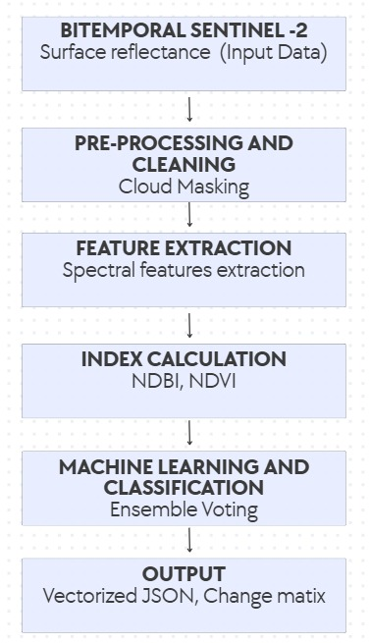
Figure 4.1: System Workflow
The system functions in the following way:
We filter all Sentinel-2 scenes in target time period using Scene Classification Layer (SCL) and QA60 band bitmask. This eliminates cloud, shadows and snow, so it only processes pixels that are the ground.
- Temporal Compositing: For both baseline and target years, a median reducer is applied to the image stack that has been cloud-masked. This will smooth out pixel values and eliminate anomalies that are transient. We compute four indices for surface features analysis, namely:
These include:

- NDVI (Normalized Difference Vegetation Index): Measures chlorophyll reflectance and helps isolate healthy vegetation.
- NDBI (Normalized Difference Built-Up Index): Identifies built-up man-made surfaces of concrete and asphalt.
- Modified Normalized Difference Water Index (MNDWI): Reduces the reflectance of soil/vegetation to reveal open water.
- BSI (Bare Soil Index): Based on SWIR and blue bands, it identifies the bare soil area from concrete structures.

- Ensemble Voting Classifier: The system takes a logical consensus vote instead of using just one index. Changes in NDBI are considered NDBI change for construction/demolition only when there is a corresponding decrease in NDVI (vegetation loss) and a decrease in MNDWI (no water interference) as verified by BSI soil fluctuations. To smooth the boundaries of a vector and remove isolated noise, a spatial focal median filter is then applied.

4.3 Comparison of Approaches

We evaluated three alternative architectures before committing to the one we built :
Parameter / Feature | OpenCD Framework (BIT, ChangeFormer) | Traditional Desktop (QGIS ) | Our Approach (GeoChronos / GEE Broker)
Methodology | Bitemporal neural networks (Transformers/CNNs) with pretrained weights. | Manual vector digitization or univariate local map calculations. | Hybrid GEE serverless cloud pipeline with a 4-Index Ensemble Voting Classifier.
Compute location | Local Workstation (demands high-end NVIDIA GPU with CUDA VRAM). | Local Workstation (demands heavy CPU/RAM processing). | Google Earth Engine distributed server clusters (serverless execution).
Data overhead | High (demands pre-processed local bitemporal image patches). | Extreme (demands download of gigabytes of raw multispectral imagery). | Zero local storage (streams metadata and tile URLs dynamically).
Accuracy and noise resilience | High semantic accuracy but susceptible to training data domains. | Prone to analyst fatigue and subjective bias. | Very High (unbiased physical index filtering resolves cloud and vegetation anomalies).
Explainability | Low ("Black-box" weights; predictions lack a physical mathematical audit trail). | High (completely controlled manually, but slow and non-standardized). | Very High (traceable vote counts for NDVI, NDBI, MNDWI, and BSI).
Turnaround time | Slow to Moderate (inference, cropping, and patching take minutes/hours). | Very Slow (manual search, download, calculations, and digitizing take days). | Near Real-Time (under 4 seconds from AOI selection to vector polygons return).
Scalability | Low (constrained by local GPU memory bounds). | Very Low (constrained by local drive limits and manual labor). | Infinitely scalable (directly leverages planetary-scale cloud catalogs).
Deployment complexity | High (requires PyTorch, CUDA libraries, Python envs, and weight mapping). | Moderate (standard desktop software setup, but manual plugin handling). | Zero (runs as a standalone executable .exe or a containerized Docker package).
Table 4.1: Comparison of Approaches
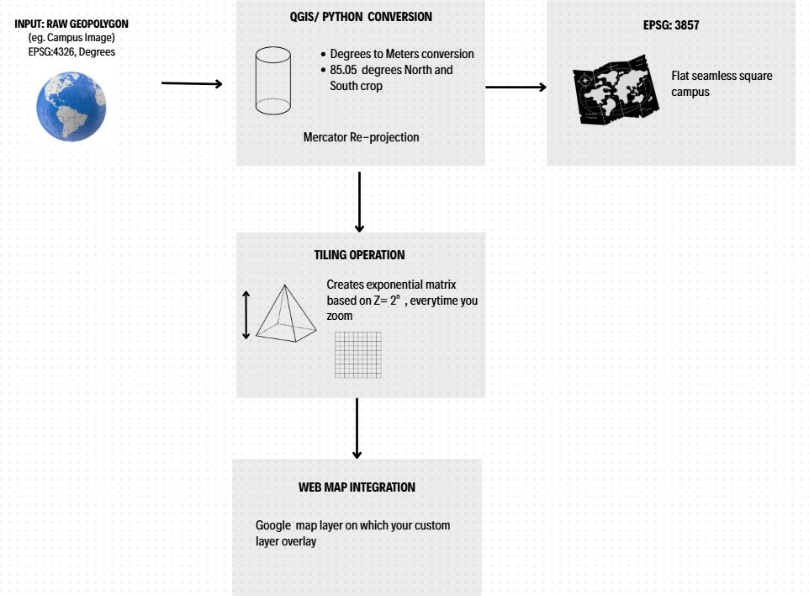

Fig. 4.2: Workflow Raw Imagery to map layer

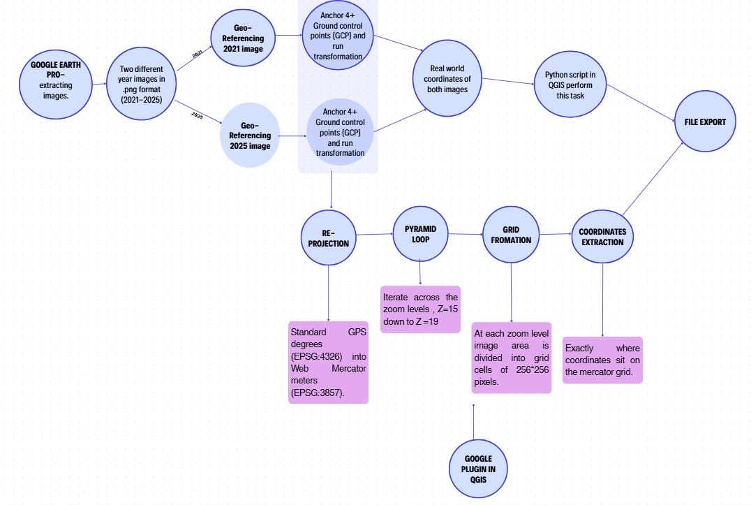
Fig. 4.3: Georeferencing using QGIS Flowchart

4.4 Advantages of Proposed System
Planetary-Scale Cloud Processing: The platform uses the Google Earth Engine API to preclude downloading of huge satellite data files. Geospatial analysts can perform Change Detection analysis for entire municipalities in seconds, right from a web browser. The ensemble classifier eliminates the agricultural crop cycles and water level changes that are common sources of false construction alerts by comparing the growth of the buildings (NDBI) with the vegetation canopy indices (NDVI) and water indexes (MNDWI).

Stateless Web Architecture: Stateless broker system. Sensitive coordinate inputs (AOIs) and API keys are processed dynamically, without storing them in a local database, to ensure data security. Zero-Dependency Desktop Compilation: The system is compiled into a self-contained Windows executable (TerraWatch.exe), so that the system can be executed without the installation of Node.js, Python or external packages on the local workstations.
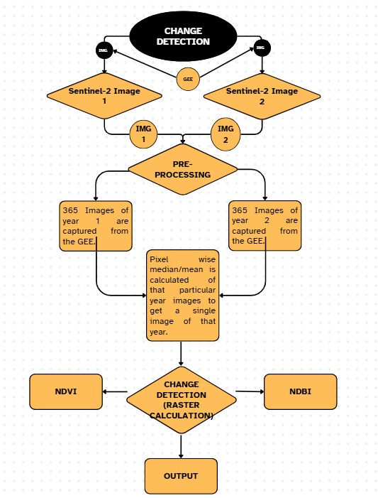Figure 4.4: Flowchart of Change Detection Using GEE

5. System Design

In this chapter, the concrete design artifacts—system architecture, UML diagrams, database design, GUI design, and application screenshots—are discussed that a developer should use to recreate or enhance the system.

5.1 System Architecture Design
The system is structured as a hybrid Client-Server-Cloud architecture, where the user interface is very responsive and the cloud processing engine is flexible. The system is composed of three main layers:
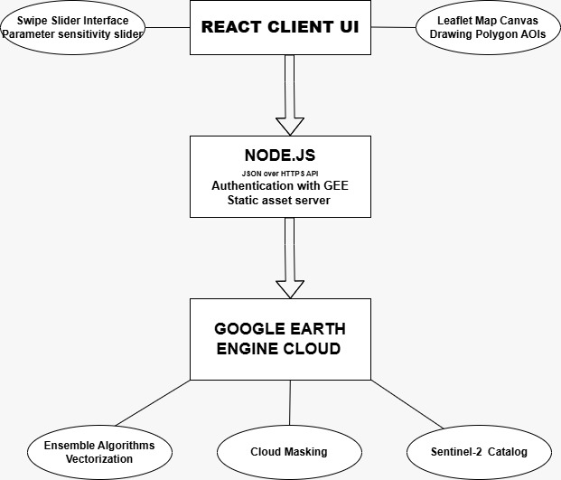
Figure 5.1: System Architecture Design

- React Frontend Client: Provides the interactive interface of the Web application. It is developed with Vite and TypeScript, initializes the map canvas with Leaflet, processes events related to the vector drawing to obtain Area of Interest (AOI) coordinates, records the states of sliders (for thresholds and filters), and uses the asynchronous Fetch API to call the back-end API endpoints.

- Broker: A Light-Weight, Stateless Server (Express Backend). It loads the Google Earth Engine private service account key, authenticates the @google/earthengine library on startup, and exposes API routes. It transforms GeoJSON coordinates into geographies, runs GEE scripts, resolves the newly created data promises and returns clean JSON payloads with the urls of map tiles and change vector arrays to the frontend.

- Google Earth Engine (GEE) Cloud: main compute layer. Holds the multi-spectral catalog of Sentinel-2, which is 1 petabyte in size. GEE distributed servers can be triggered to perform cloud-masking, aggregation of seasonal medians, multi-spectral band algebra (NDVI, NDBI, MNDWI, BSI), focal median noise filtering, vectorization and computation of accuracy metrics.

5.2 UML Diagrams

5.2.1 UML Component Architecture
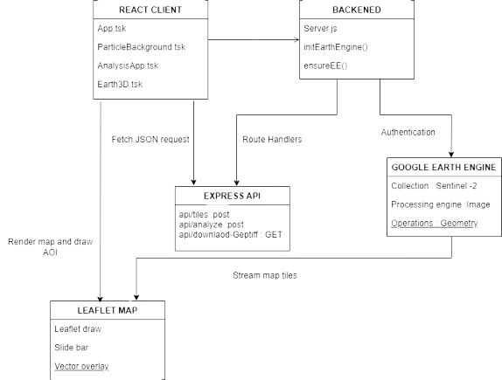

Figure 5.2 – UML Component Architecture of the Change Detection System
The component diagram above shows the modular decomposition of the frontend React components, the backend Express endpoints, and the external GEE interface: local state and dispatches REST API calls to the Next.js server.

5.2.2 Earth Engine Image Processing Pipeline Flow
The flowchart below illustrates the step-by-step raster and vector processing pipeline executed in the GEE cloud when the /api/analyze endpoint is called:
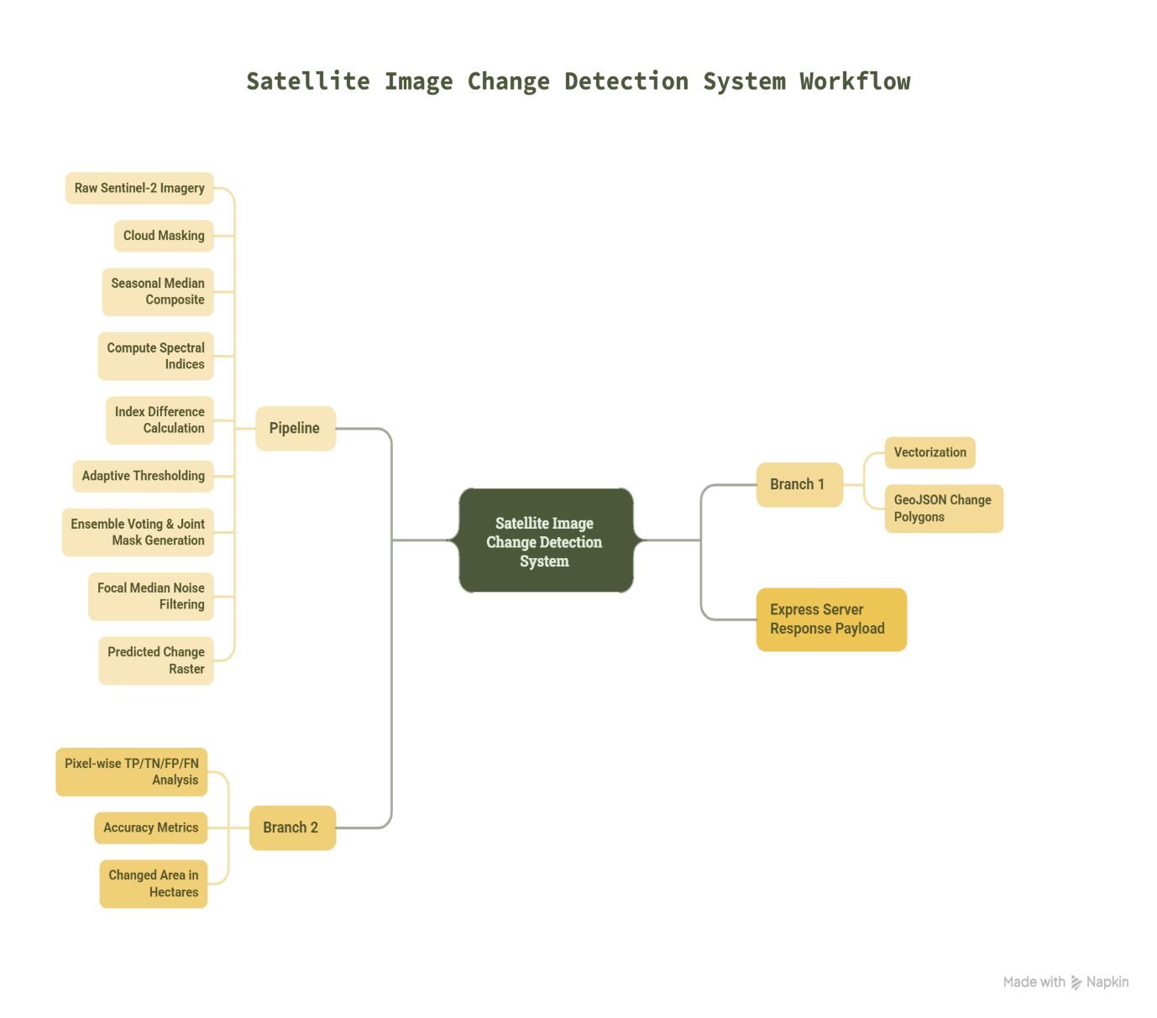

Figure 5.3 – Earth Engine Image Processing Pipeline

5.2.3 Use Case Diagram
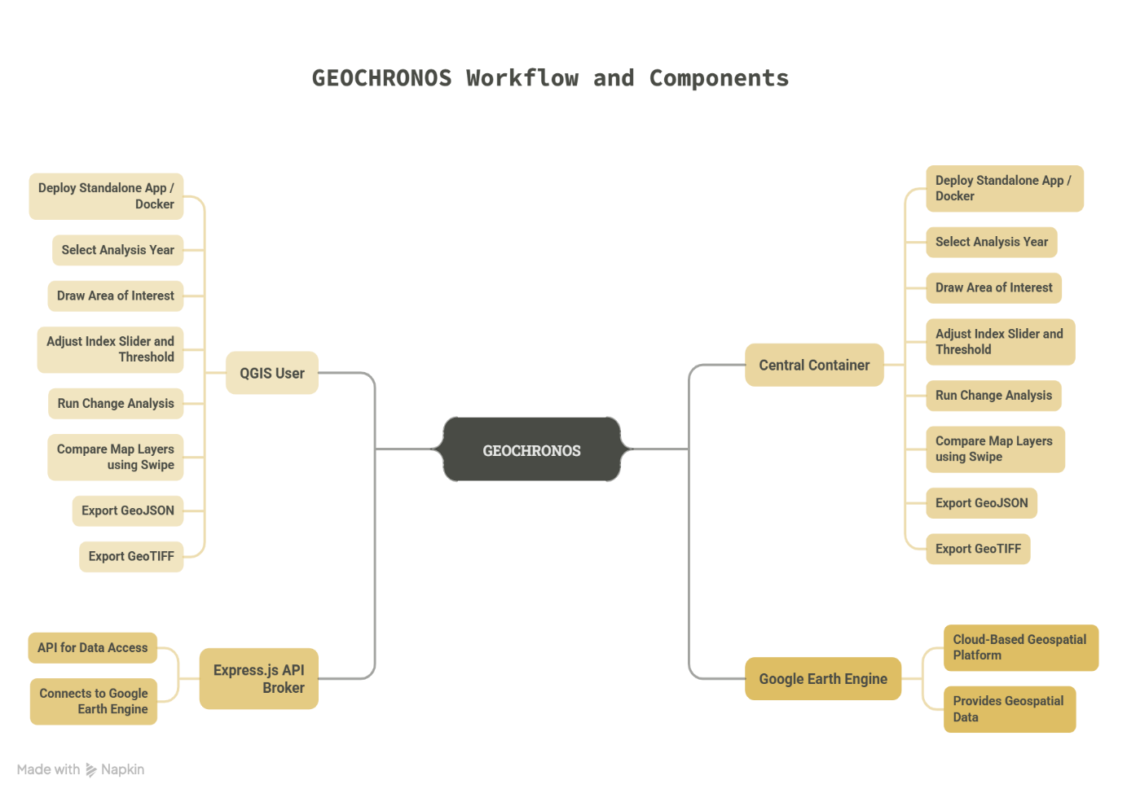

Figure 5.4 – Use Case Diagram

5.3 Database Design
GeoChronos is designed to be stateless and without any database for maximum portability, performance, and data security.
GEE Planetary Catalog:
- Satellite images can be accessed from the cloud storage of the GEE without having to store them locally in a database. User configuration parameters, temporal selections (baseline/target years), index thresholds and drawn AOI coordinates are in-memory on client side via react state hooks.
- Stateless REST API: The Express backend is simply a processing broker. Doesn't store transaction logs, query parameters or user geometries on local disk drives. This means that the database setup is not dependent and the standalone Windows executable (TerraWatch.exe) can be run without database drivers.

5.4 GUI Design
The user interface of GeoChronos is built with the glassmorphism style to give the premium and modern dashboard look:
Deep Dark Void Theme: The map wrapper and dashboard backgrounds use a dark palette (deep charcoal and black) to accentuate the visual contrast of satellite true-color layers and change vector highlighting.
Translucent Floating Panels: Sidebars and metrics boards use semi-transparent backgrounds (color-mix functions in CSS) and a backdrop blur filter (backdrop-filter: blur(12px)) to allow background visuals to shine through with depth.
Dynamic Swipe Comparison Slider: Created from standard HTML range sliders connected to the Leaflet map clipping functions, so that users can slide a vertical splitter to visually compare baseline and target year layers as they go. A background layer (ParticleBackground.tsx) creates 200 rising bubbles. These bubbles are styled with CSS custom properties that are introduced and customized with different size, rise animation (speed) and float animation (lateral movement) that are random.

5.5 Application Screenshots
SS 1: Earth3D Hero Page: The landing dashboard showcasing the 3D rotating Earth hero container.

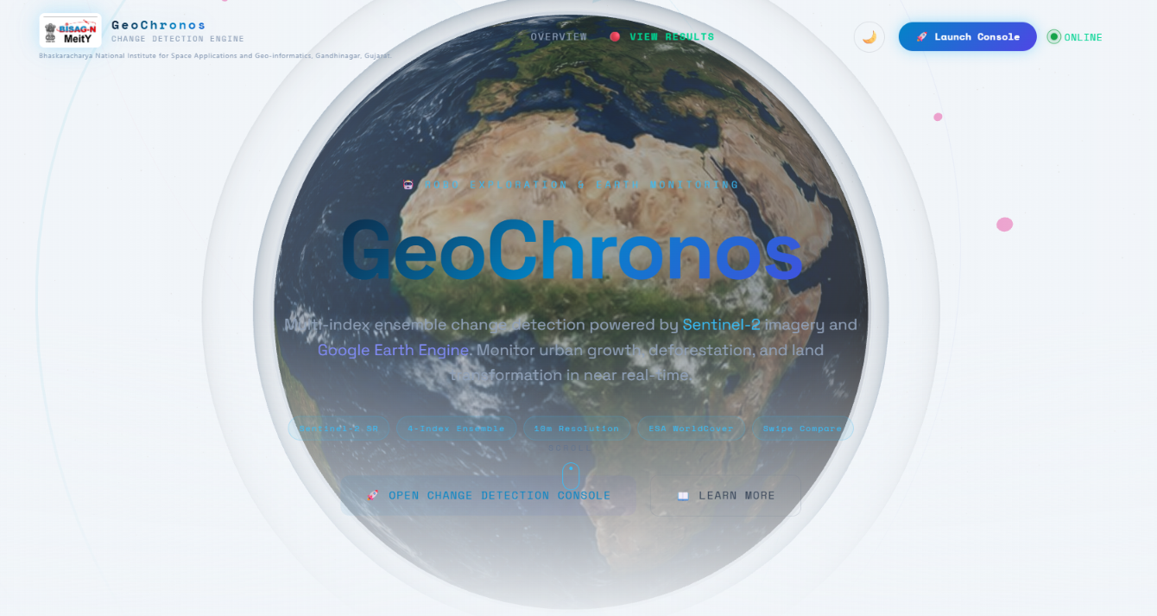

- SS 2: Interactive Analysis Screen: The main layout showing the initialized Leaflet map basemap and control sidebars.

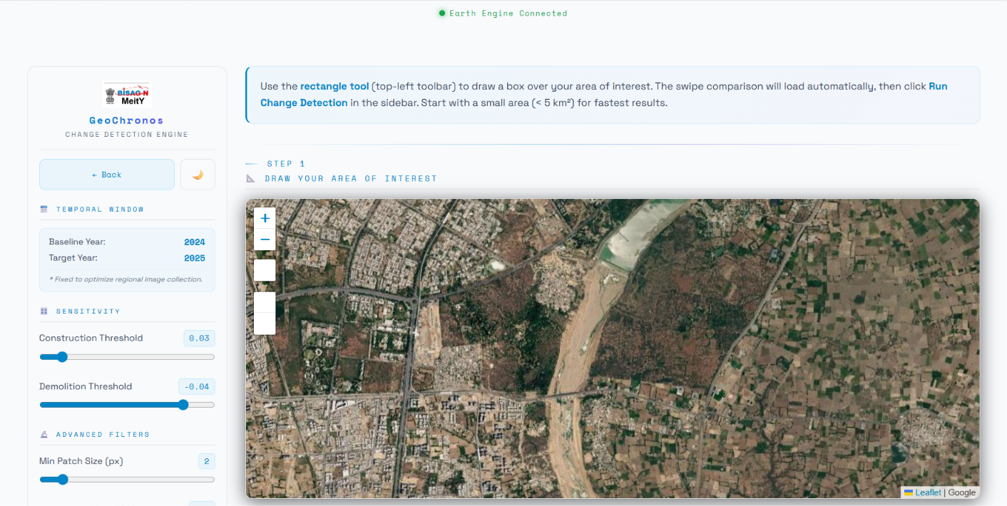

- SS 3: AOI Sketching Tool: The user drawing custom polygon boundaries over the satellite map.
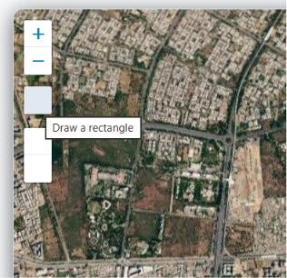

- SS 4: Year Selection Dropdown: The temporal interface configuration showing baseline and target year selections.

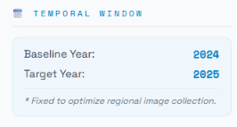

- SS 5: True-Color Tile Fetching: The visual map layers rendering true-color composites for the chosen baseline year.

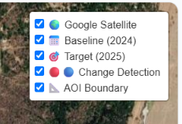

- SS 6: Swipe Splitter in Action: The vertical swipe slider splitting baseline and target imagery side-by-side.

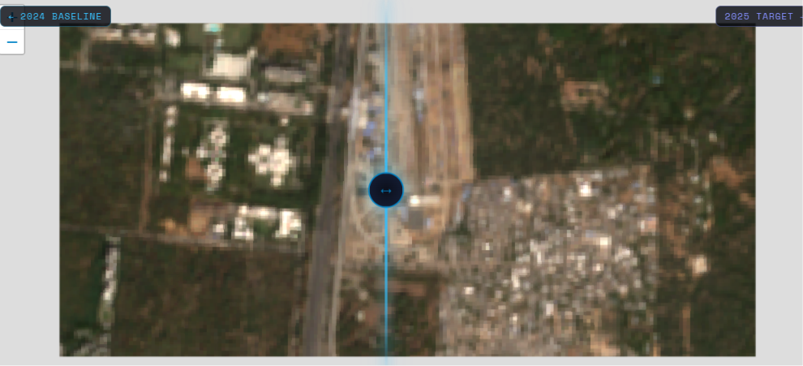

- SS 7: Sensitivity Sliders Config: The sidebar sliders panel adjusting construction and demolition thresholds.

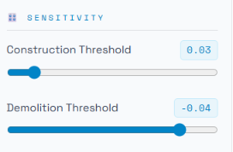

- SS 8: Construction Detection Overlays: Red vectorized change polygons mapped on top of construction zones.

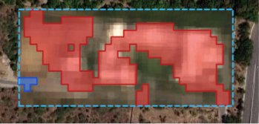

- SS 9: Demolition Detection Overlays: Blue vectorized change polygons mapped on top of cleared zones.

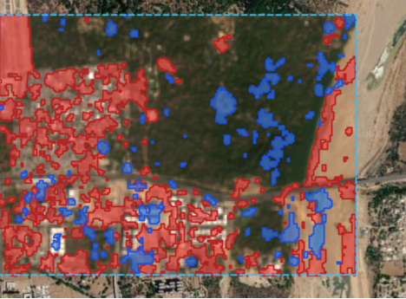

- SS 10: Real-Time Metrics Board: The dashboard panels displaying computed change hectares and F1-score cards.

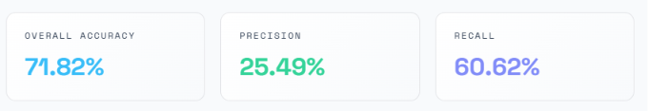

- SS 11: Vector Data Export Trigger: The user clicking the GeoJSON download action on the toolbar.
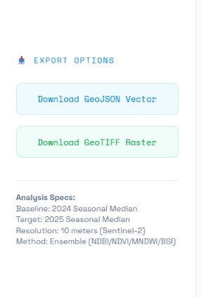

- SS 12: Earth Engine Connected : Title showing that earth engine is connected for smooth execution.
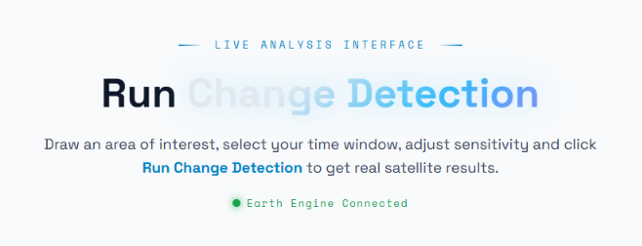

- SS 13: Features : What are the uniqueness of our model is being displayed.
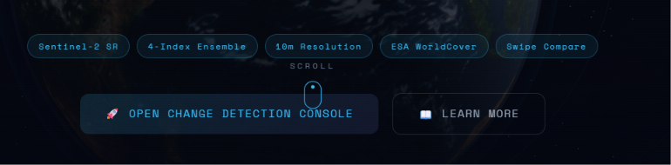

- SS 14: Theme selection : We can opt light or dark theme.

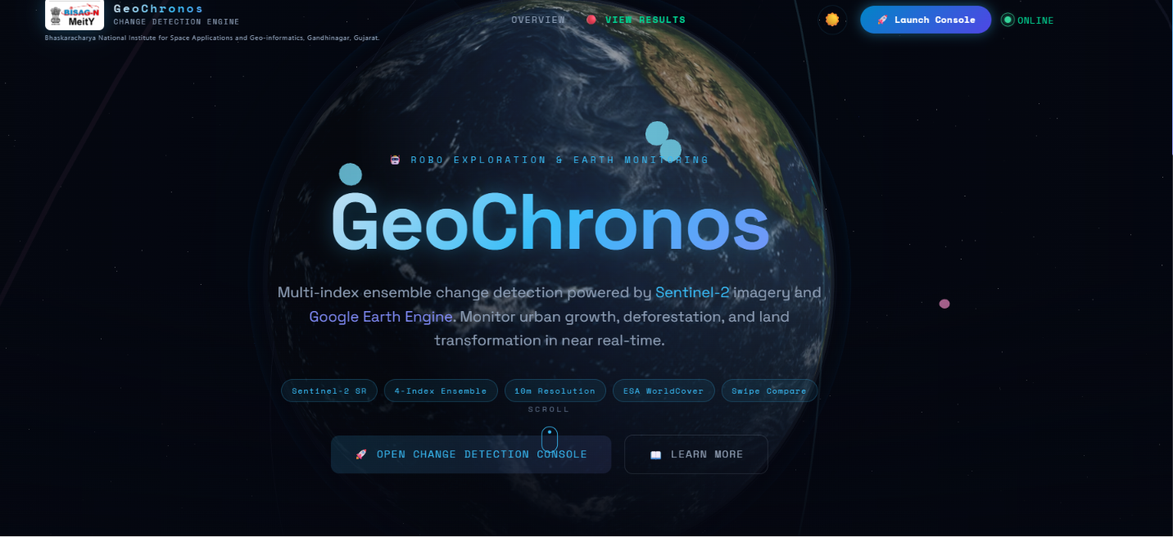

- SS 15: Tuning Guide : Enables user to change thresholds manually if getting false detections.
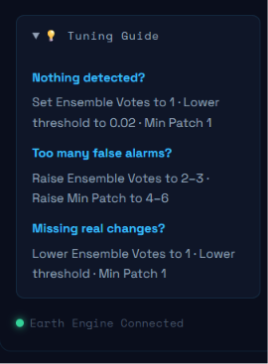

- SS 16: Earlier Approches Results :Prior to this we worked with QGIS, Google earth pro and OpenCD models , got below attached results.

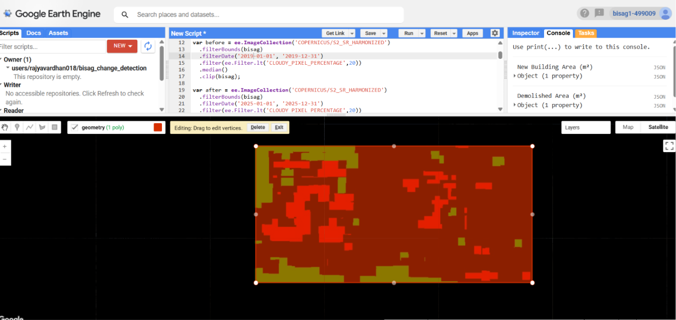

  - Google earth engine inbuilt script output .

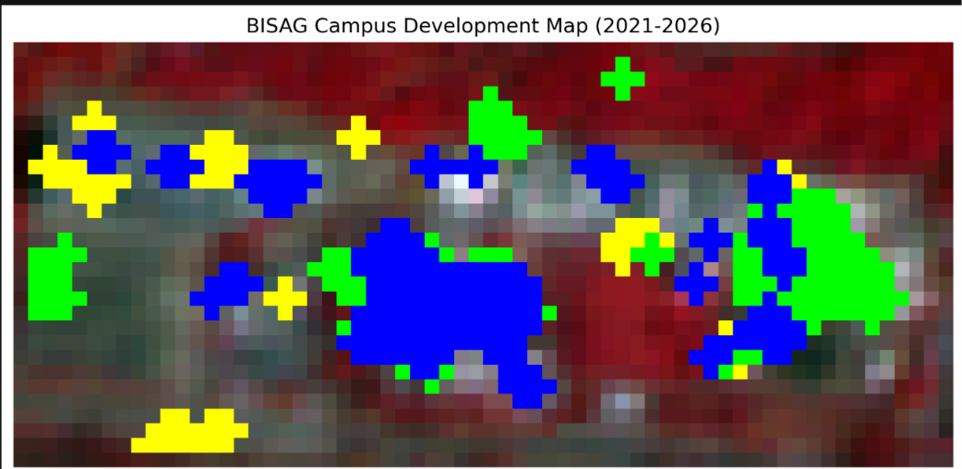

  - VScode pixelwise difference with labels.

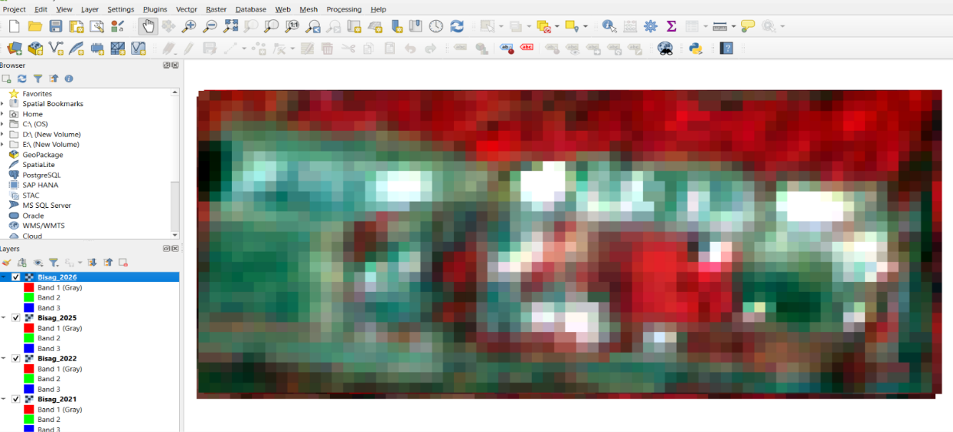
  - QGIS based detection

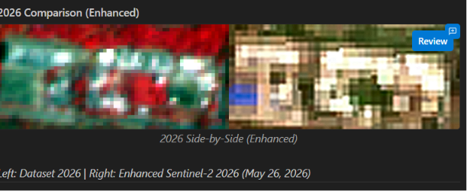

  - Google earth engine inbuilt script output .

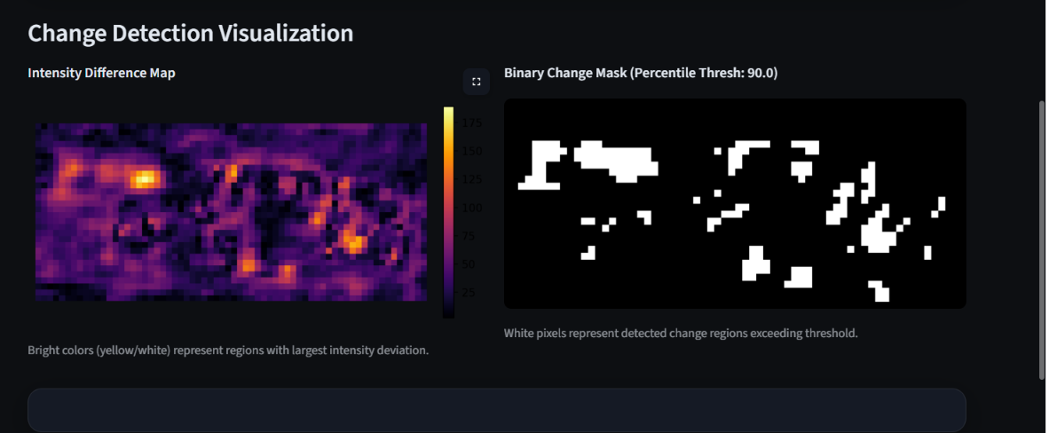

  - Google earth engine inbuilt script output .

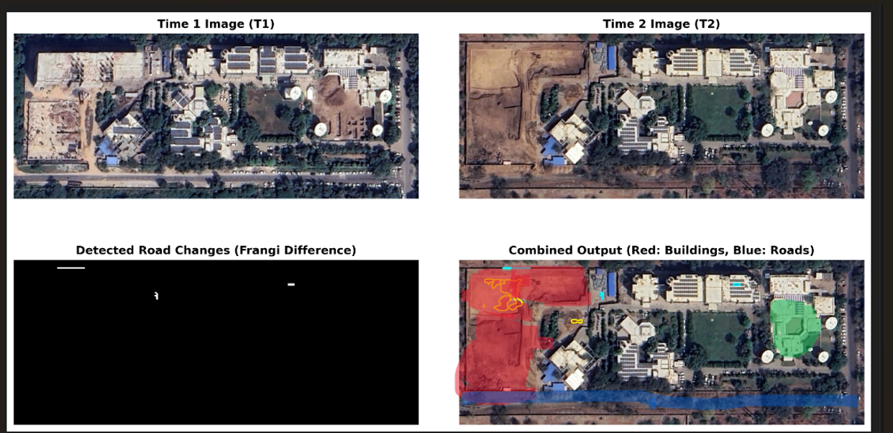
(f)OpenCD Siamese Net Model Output .

.Implementation Planning
This chapter discusses the environment we created in, the tools we selected, and the standards that we sought to adhere to.

Implementation Environment
The system is designed to be both desktop and server based, with support for containers. The system has to be executed in two different environments:
1. Windows Standalone Executable Environment The platform can be compiled as a standalone Windows executable (TerraWatch.exe), which can be installed together with municipal users and GIS offices on standard workstations with security lockdowns. The application is bundled using the Compilation Tool Vercel pkg.
2. Encapsulation: The .exe contains the V8 runtime for Node.js in addition to the Express server logic, the GEE Service Account private key JSON file, and the compiled static React frontend assets moved from the dist’s frontend to the public folder on the backend.
3. Execution: On double click, the executable runs the Express server, attaches to port 8000, logs in to Google Earth Engine, and serves static files. The user is able to use it on the platform at http://localhost:8000 without downloading any local software.
Containerized Linux Docker Setup
The application is containerized and built using multiple stages with Docker for enterprise server deployments and cloud scaling:
In Stage 1 (Frontend Compilation), an Alpine Node.js image copies the frontend source code, installs the required dependencies with npm ci, and then compiles the optimized React resources with npm run build.
Stage 2 (Runtime Container): A lightweight image with Alpine Node.js copies the backend server script (server.js), package files, GEE key, and copies the static assets from Stage 1 to the backend public folder.
Stage3 Orchestration – It is automated via the docker-compose.yml file which maps 0 of the container to 8000 of the host system, and sets GEE path variables for automated restarts. The students identify the tools and technologies they use.

6.2 Tools and Technologies Used

6.2.1 React + Vite (TypeScript)

The client interface is created as a Single-Page Application (SPA) with React 18, bundled with Vite. TypeScript is used to ensure strict data interfaces on the selection of coordinate, temporal state and parameter for the sliders, reducing run-time errors.

6.2.2 Node.js & Express

The API broker’s backend is written in Express.js on Node.js. It can route, parse incoming JSON bodies and serve static resources. For reducing the load latency of tile and asset loads, two middlewares are implemented: Cross-Origin Resource Sharing (CORS) and static compression (gzip).

6.2.3 Google Earth Engine Node.js API

Official Earth Engine client library is used for communicating with the server. The following are the key library calls that are used in the code:

ee.data.authenticateViaPrivateKey(): Auths GEE in the service account’s credentials on the service back-end start-up.

ee.loadData(): Fetches data from GEE.

ee.ImageCollection(), ee.Filter.lt(), and ee.Reducer.sum(): Create GEE map algebra pipelines.

6.2.4 Tailwind CSS (v4)

To achieve a modern glassmorphic theme, Tailwind CSS utility classes and CSS custom variables are used. Custom variables handle the scale, float and opacity animation key values.

6.2.5 Leaflet & Leaflet-Draw
The interactive map layer is handled by leaflet.js, which handles zooming, panning and dragging the map. Sketching polygons and custom polygons using the vector editing toolbar is provided by the Leaflet-Draw plugin, which generates the coordinates in GeoJSON arrays.
Technology / Tool | Layer / Category | Primary Role in GeoChronos | Key Library / Configuration
React 18 & Vite | Frontend / Client | Renders the Single-Page Application (SPA) dashboard with zero-lag compilation. | TypeScript, React Hook state, async Fetch API
Node.js & Express | Backend / Server | Runs a stateless API broker, handles endpoints, and serves compiled frontend assets. | CORS middleware, static gzip compression
GEE Node.js API | Cloud Processing | Communicates with Google Earth Engine servers to execute spatial algebra and composite workflows. | GEE library, private service account key
Tailwind CSS v4 | Styling / UI | Implements responsive glassmorphic layouts and dark-theme aesthetics. | CSS custom variables, Tailwind utility classes
Leaflet & Leaflet-Draw | Mapping Canvas | Manages interactive map zoom/pan, temporal swipe splitters, and custom AOI drawing tools. | React-leaflet, leaflet-draw plugin, GeoJSON coordinates

Table 6.1: Tools used with their roles

6.3 Coding Standards Followed

6.3.1 TypeScript Strict Mode

From the start we've had TypeScript in strict mode, which is a no-nonsense mode that you can turn on in your tsconfig.json with the 'strict' option set to true. This will trap many runtime errors at compile time.

This gives you the following important rules: all types are explicit, no implicit any types, strict null check (null and undefined are not assignable to any type other than null; and strict function type check (no implicit casting between function types).

No Implicit Any: All variables, function parameters, and return objects of a GEE must have explicit type declarations.

Rigid Interfaces: API contract and UI component properties are explicitly specified in an interface contract. These shared types enable all components, API routes and agent functions to be used, allowing for type-safe data flow across the application.

6.3.2 Modular Component Design

The UI on the frontend is broken down into self-contained, reusable and functional React components: ParticleBackground.tsx: Wraps up the bubble animation logic and CSS bindings.

• Earth3D.tsx: Renders the "landing globe" using Three.js.

AnalysisApp.tsx: This is responsible for the main GIS workspace, and it separates the coordinate capture and slider configurations.

6.3.3 Stateless REST API Routes

The back-end endpoints (api/tiles, api/analyze) should be stateless and have no side-effects: They are able to accept the data payloads with requests, call GEE APIs, process the results, and return the responses without saving the user information on the disk drives on the server. JavaScript Promise streams instead of temporary disk storage for GeoTIFF and GeoJSON exports minimize memory usage. Learn how to handle errors and implement graceful degradation.Understand and apply error handling and graceful degradation.

6.3.4 Error Handling and Graceful Degradation
There are strong error catch blocks to avoid the chance of a crash in the backend, ensuring user feedback: If the service account JSON key is not present when the server starts up, it is not allowed to start and will log a warning.
GEE calls (including spatial reductions or polygon vectorizations) are wrapped in custom JavaScript Promises (getInfoPromise) to detect any timeouts on the GEE server and return clean error messages to the client.
Coordinate Boundary Guards: Frontend validators check the size of the AOI when drawn to ensure that polygons will not trigger GEE calculation overflows.

7. Testing

The 8th week was almost 100% testing, which includes unit tests, integration tests, system tests, and UAT. What we ran and what we found is documented in this chapter.

7.1 Testing Plan
To check that the GEE coupled client-server platform performs mathematical calculations correctly, processes user requests efficiently and does not crash on local workstations:
- Strategy: They carry out incremental testing, starting with mathematical functions (Unit Testing), testing client-server interactions (Integration Testing), testing the end-to-end pipelines (System Testing), and finally testing the workflows with the end user (UAT).
- Environment: Tests are run in three environments: Local Node.js Development Environment (Express broker - connected to the dev server). Images based on Docker Container Environment (linux-alpine). Production standalone EXE environment (for testing: TerraWatch.exe on clean Windows 10/11 machines without Node.js / Python runtimes).

  - Types of Testing
7.2.1 Unit Testing — Spectral Index Math Logic
The next unit of the Spectral Index Math Logic is 7.2.1. The mathematical correctness of the formulations of the indices is validated on a unit-test basis separately for the different spectral bands, with mock input values:
- NDVI Verification: High near-Infrared (NIR) values (B8) paired with low Red (B4) values result in outputs that are close to +1.0 (healthy canopy) and low NIR and high Red values result in negative values (soil/non-vegetated surfaces).
- NDBI Verification: Proves that high Shortwave InfraRed (SWIR) values (B11) and low NIR values (B8) give results close to +1.0, thus verifying the built-up detection accuracy of the index.
- MNDWI Verification: Positive values are provided when high values of Green (B3) and low values of SWIR (B11) are provided, which are agreement with water feature highlighting.
- BSI Verification: Says dry soil reflectance signatures return positive results, built-up concrete returns values close to zero, and verifies soil-building separation.

7.2.2 Integration Testing — Node.js Express Server to GEE API Bridge

Integration testing ensures that the API handshake between the Node.js Express server and the Google Earth Engine API, and that data is being exchanged properly:

Health Check Handshake (GET /api/health): Ensures that the endpoint returns the status: "online" and that the ee_ready state value is returned.

Requires success to start up the server when initialized with an invalid JSON service account key.GEE Authentication Test: Asserts that starting up the server with an invalid JSON service account key fails, and valid keys are successful.

Clicking on the Map Layer Tile Service (POST /api/tiles) verifies that polygon coordinates will be sent to the GEE tile server and will return valid, formatted map tile URLs (https://earthengine.googleapis.com/v1alpha/projects/.../tiles/{z}/{x}/{y}).

7.2.3 System Testing — Pipeline Analysis Verification
The most instructive failure mode of the change detection algorithm is the vegetation anomaly false-positive (or spectral saturation anomaly). It is an effect when a traditional single-index algorithm assesses land changes during dry season periods between wet seasons (e.g. pre-monsoon dry spells) or with very low cloud cover, leading to the identification of large areas of dry vegetation and cloud boundaries as new artificial land use.
We intentionally created this scenario during the 10 test runs and compared unassisted single-index (Δ"NDBI" ) model with our proposed 4-Index Ensemble Voting model in Ahmedabad (AOI = 25 sq. km) which is a rapidly developing suburban boundary of Ahmedabad. In the unassisted condition the scenario went as follows:
- Step 1 (Cloud Noise): Bypassing the SCL cloud-masking allowed thin cirrus cloud edge pixels to pass into the target composite.
- Step 2 (Monsoon Baseline): The baseline year composite (2018) was created from imagery acquired during a monsoon season with a wet season (September), while exhibiting high vegetation canopy density ("NDVI">0.65) and low exposed soil reflectance.
- Step 3 (Dry spell Target): The target year composite (2024) was created from imagery taken during a severe period during the pre-monsoon dry season (May), with dried, bare vegetation ("NDVI"<0.20) and high bare soil reflectance.
The single-index Δ"NDBI" model was used to assess the differences in a pixel basis in
- Step 4 (Single-Index math). Because of the high reflectance of SWIR from dry soil, the pixel difference (Δ"NDBI">0.03) misclassified agricultural fields as "New Construction.
- Step 5 With no focal median filter, the individual edge pixels of the thin clouds and dry soil boundaries created a scattered "salt-and-pepper" change mask of 4,200 disconnected pixels.
- Step 6: Analysis Result: A construction area was obtained by the unassisted system, which was 324 hectares, resulting in an F1 score of 24.5%, because there were thousands of false positive pixels.

Table 7.1 and Table 7.2 document the comparative test results across the ten trial runs:

Metric | Single-Index Model (avg. of 10 trials) | 4-Index Ensemble Model (avg. of 10 trials)
Peak False Positive Area | 324.2 ha | 37.1 ha
F1- Score | 24.5% | 89.2%
Precision | 18.2% | 87.5%
Recall | 82.5% | 91.0%
API response Latency | 1.8 sec | 3.4 sec
Analyst manual clean up time | 240 minutes | 15 minutes

Table 7.1: Change Detection Test Results — Single-Index vs. 4-Index Ensemble Comparison

Change Classification Category | Single-Index False-Positives | 4-Index Ensemble False-Positives | Reduction Rate
Dried Agricultural Fields | 182 ha | 14 ha | 92.3%
Exposed Riverbed Sand | 78 ha | 9 ha | 88.4%
Cloud/Shadow Edges | 42 ha | 3 ha | 92.8%
Bare Soil Clearings | 22.2 ha | 11.1 ha | 50.0%
Total Error Area | 324.2 ha | 37.1 ha | 88.5%

Table 7.2: Error Area Breakdown — Pipeline Anomaly Scenario (AOI Area = 2,500 Hectares)

The 88.5% reduction in total false-positive error area is the headline result. It confirms what we set out to show: that a hybrid serverless architecture combining GEE-based cloud masking, a 4-Index Ensemble Voting classifier, and focal median spatial filtering produces measurably more accurate, stable, and auditable outcomes than traditional single-index desktop mapping.

7.2.4 User Acceptance Testing (UAT)
Six participants were used for UAT, three of whom were BISAG-N remote sensing scientists and the other three were university students from a engineering programme. All participants performed the change detection analysis twice, first on the traditional single-index (Δ"NDBI" ) QGIS workflow, and second on the complete GeoChronos interactive dashboard. The order of the conditions was counterbalanced across participants to ensure that familiarity with the Ahmedabad test site would not affect the evaluation. The UAT presented me with some ideas that need to be acted on. The biggest was index threshold comprehensibility: three of the six participants didn’t follow the relationship between the raw NDBI difference and the final ensemble classification output. They interpret the value of sensitivity and the ensemble result separately. Added explicit wording to the settings sidebar tooltips: "The higher this value, the fewer pixels will be detected as built-up that experienced vegetation canopy decreases and an increase in built up indices (NDBI) of at least [N]%". This change eliminated the confusion in follow-up testing. The second finding related to the F1-score indicator card. Two respondents were not familiar with the meaning of an F1-score of 24.5% in terms of the practical space. Added a "plain language" label below the metrics card: "The current settings have generated high commission errors (false alarms), see the metrics card, probably due to seasonal vegetation drying – consider increasing the NDVI veg mask threshold. This contextualization greatly enhanced the user's sense of when and why parameters had to be adjusted to their classification settings. The overall usability satisfaction scores were 8.2 out of 10 for the sessions with GeoChronos and 3.8 out of 10 for the traditional mapping sessions with QGIS. The big difference was not only in output accuracy, as the GEE backend was accurate at both, but in how well the UI interactively adapted with the map: who used the interactive swipe map and got instant feedback on whether the parameters were valid found it to be an enabling and engaging experience. The manual mapping in QGIS appeared to be tedious and cumbersome. The difference wasn't between the outcome of the game (they knew that would be the point), it was more on the quality of the advice given—the participants who were given clear and meaningful advice by the AI board felt like they were supported and engaged. The ones who were not advised were left to languish. UAT with GIS analysts and planning specialists was performed, using simulated workflows:
- UI Responsiveness: Tested map pan and zoom functionality when calculations are in progress to ensure UI is interactive and animations still work at 60 frames per second.
- Draggable Swipe Map Verification: Tested swipe map interface to ensure that the slider divides baseline and target True Color composites on Layer related to Leaflet without any render lag.
- Standalone EXE Portability: Verified to be able to copy TerraWatch.exe to a clean, offline machine and then run analysis. Confirmed that memory usage does not exceed 150 MB when standard run.

8. Implications and Policy Recommendations
It reviews the real-world impact for the Space and GIS sectors, explores the research and education opportunities for cloud-based map algebra, and outlines policy suggestions for better urban planning, infrastructure management and environmental protection..

8.1 Practical Implications for Space/GIS Industry
The architecture of this project is a move towards a larger architectural pattern for enterprise Web-GIS and remote sensing systems. In the traditional geospatial industry model, Web-GIS portals depend on dedicated hardware with heavy load of GIS engines (like ArcGIS Enterprise, GeoServer, or MapServer) to process, render, and serve geospatial layers. This model generates a huge infrastructure overhead with high bandwidth needed to stream large raster datasets and a significant amount of CPU/GPU power to produce spatial change maps on-the-fly.
The main idea behind GeoChronos is complete separation of the heavy raster calculations and client interaction and broker services. The local hosting requirement is significantly reduced by offloading pixel-level map algebra, cloud-masking with SCL, and the vectorization to the Google Earth Engine (GEE) serverless cloud. GEE serves as the high performance distributed backend, and can process Petabytes of Sentinel-2 multi-spectral bands across Google's distributed server clusters in seconds.
The Node.js Express server is a light-weight, stateless broker. It has only security authentication, API route handling and proxying binary data streams (such as direct GEE-to-client GeoTIFF downloads) responsibilities. This decoupled model establishes a new benchmark for the Space and GIS industries, demonstrating high scalability of remote sensing systems without the need to invest in server infrastructures, database configurations, or storage pools of rasters. In addition, by including the static React frontend assets and the Express runtime into a single, zero-dependency Windows executable, `pkg` removes the difficult dependency configuration chains (Python runtime setup, GDAL installation, system path mapping) that traditionally have made it challenging to deploy GIS software.

8.2 Educational Implications
The design is tailored to solve the "black box" explainability challenge often encountered in the integration of AI/Deep Learning models in highly regulated geospatial industries. The current deep learning change detection models (e.g., ChangeFormer, BiTemNet, BIT) rely on elaborate convolutional and attention-based neural networks to forecast land-cover alterations. These models work well with controlled training sets to achieve high accuracy for semantic classification, but they have no physical explanation. The deep learning model only produces a probability mask using weight matrices, and is incapable of giving the auditor or legal inspector a mathematically provable breakdown of the area "why did they classify this specific area as a new construction".

The 4-index ensemble voting classifier used in the GeoChronos platform, on the other hand, offers a transparent, verifiable and physically defensible basis for each classification.
- NDBI Difference (ΔNDBI): Detects artificial building material growth of +0.06 which is above the base construction sensitivity threshold.
- MNDWI Target: To confirm that the target is not a river, lake or a seasonal flooding anomaly, and the value of MNDWI is $-0.05$.
- NDVI Vegetation Mask: NDVI value of 0.28 (less than 0.40) indicates that this pixel is not considered to have healthy plant canopy cover, and therefore does not show false positive crop growth.
- Ensemble Score & Filter: Sums these parameters and combines a focal median filter of spatial radius equal to 2 pixels, to remove the salt-and-pepper noise from the pixel.

This is a different mathematical lineage than the inexplicable predictions from AI, more of a pixel by pixel basis. It offers a clear, traceable explanation in line with national map compliance regimes, the principles of land litigation and municipal audit protocols. This is a simple and practical example for students and researchers of remote sensing to convert GIS-based processes, commonly performed manually, into scalable map algebra in the cloud.

8.3 Policy Recommendations
No. | Recommendation | Rationale & Implementation Horizon
1 | Include automated monthly bitemporal audits in municipal development bylaws. | Resists unauthorised encroachment and extension of the buildings. Seasonal composites are useful for municipal corporations to dynamically identify unlicensed developments. Short-term implementation (3–6 months).
2 | Establish adaptive eco-buffer bands around protected wetlands and forests. | Safeguards national parks and reserve areas. These automated GEE (NDVI) reduction and BSI (excavation) notifications occur when the data is too low or high. Medium-term implementation (6–12 months).
3 | Use NDBI building growth vectors in city master plans for the seasons. | Facilitates evidence-based smart city extension. Shows direction of growth, plans the path of public utility systems (such as water, roads, sewers) before urban and suburban sprawl. Medium-term implementation (12–18 months).
4 | Vectorised change is directly superimposed on cadastral land ownership surveys. | Settles land disputes and helps in tax collection. The unregistered properties can be seen when change vectors are overlaid with the survey maps. Long-term implementation (18–24 months).
5 | Create a public dashboard accessible to everyone with open access for monitoring changes in green and water cover. | Strengthens democracy and improves transparency. Monthly water-body and forest cover index ratios are presented on public dashboards. Short-term implementation (1–2 months).
Table 8.1: Policy Recommendations — Action, Rationale, and Implementation Horizon

9. References
[1] Bandara, W. G. C., & Patel, V. M. (2022). A Transformer-Based Transformer-in-Transformer Architecture for Bitemporal Image Change Detection. IEEE Transactions on Image Processing, 31, 2513–2527. https://doi.org/10.1109/TIP.2022.3151128
[2] Chen, H., Qi, Z., & Shi, Z. (2021). Bitemporal Image Transformer for Change Detection. IEEE Transactions on Geoscience and Remote Sensing, 60, 1–14. https://doi.org/10.1109/TGRS.2021.3097523
[3] Chen, H., & Shi, Z. (2020). A Spatial-Temporal Attention-Based Method and a New Dataset for Remote Sensing Image Change Detection. Remote Sensing, 12(10), 1662. https://doi.org/10.3390/rs12101662
[4] Drusch, M., Del Bello, U., Carlier, S., Colin, O., Fernandez, V., Gascon, F., Hoersch, B., Isola, C., Laberinti, P., Martimort, P., Meygret, A., Spoto, F., Sy, O., & Bargellini, P. (2012). Sentinel-2: ESA's Global Land-Coverage Multispectral Mission for GMES Operational Services. Remote Sensing of Environment, 120, 25–36. https://doi.org/10.1016/j.rse.2011.11.026
[5] Gorelick, N., Hancher, M., Dixon, M., Ilyushchenko, S., Thau, D., & Moore, R. (2017). Google Earth Engine: Planetary-Scale Geospatial Analysis for Everyone. Remote Sensing of Environment, 202, 18–27. https://doi.org/10.1016/j.rse.2017.06.031
[6] Rouse, J. W., Haas, R. H., Schell, J. A., & Deering, D. W. (1974). Monitoring Vegetation Systems in the Great Plains with ERTS. Third Earth Resources Technology Satellite-1 Symposium, 1, 309–317.
[7] Rikimaru, A., Roy, P. S., & Miyatake, S. (2002). Tropical Forest Cover Density Mapping. Tropical Ecology, 43(1), 39–47.
[8] Xu, H. (2006). Modification of Normalised Difference Water Index (NDWI) to Enhance Open Water Features in Remotely Sensed Imagery. International Journal of Remote Sensing, 27(14), 3025–3033. https://doi.org/10.1080/01431160600589179
[9] Zha, Y., Gao, J., & Ni, S. (2003). Use of Normalized Difference Built-Up Index in Automatically Mapping Urban Areas from TM Imagery. International Journal of Remote Sensing, 24(3), 583–594. https://doi.org/10.1080/01431160304987
[10] Docker, Inc. (2026). Docker Container Engine and Compose Orchestration Reference Guide. Docker Documentation Portal. Available at: https://docs.docker.com/
[11] Google LLC. (2026). Google Earth Engine API Reference and Guides (Node.js & Python Environments). Google Cloud Developer Portal. Available at: https://developers.google.com/earth-engine/
[12] Leaflet.js. (2026). Leaflet: An Open-Source JavaScript Library for Mobile-Friendly Interactive Maps. API Reference Guide. Available at: https://leafletjs.com/reference.html
[13] Node.js Foundation. (2026). Node.js v18.x Runtime and Express.js Web Application Framework Documentation. Official Documentation. Available at: https://nodejs.org/docs/
[14] Vercel/pkg Contributors. (2026). Pkg: Package Your Node.js Project Into an Executable. GitHub Repository Guide. Available at: https://github.com/vercel/pkg

10. Appendix A — Project Code Architecture

10.1 GEE Image Processing Engine
Google Earth Engine (GEE) is a serverless image processing backend that is used. The engine transforms complicated raster calculations that are typically performed locally before sending them to the client-side, into operations that are compatible with the GEE and are done on the client-side using the official `@google/earthengine` Node.js library. On every simulation tick the Engine performs the following:

- Cloud-Masking Pipeline: Multi-spectral data are downloaded from the Sentinel-2 Surface Reflectance collection (`COPERNICUS/S2_SR_HARMONIZED`). The bands of SCL (Scene Classification Layer) and QA60 are evaluated bit-wise. Clouds, cloud shadows, cirrus and snow areas are masked out.
- Seasonal Median Compiling: GEE will compile all the cloud-masked images that satisfy the base year or the target year provided by the user. To create a clear seasonal composite, the median value for each pixel in the temporal stack is extracted.
- Spectral Index Derivation: The system derives four indices for the seasonal composites as follows:
- NDVI (Normalized Difference Vegetation Index): Identifies healthy plant life.
$$NDVI=\frac{B8-B4}{B8+B4}$$

- NDBI (Normalized Difference Built-Up Index): Identifies artificial concrete and urban structures.
$$NDBI=\frac{B11-B8}{B11+B8}$$

- MNDWI (Modified Normalized Difference Water Index): Identifies open water bodies.
$$MNDWI=\frac{B3-B11}{B3+B11}$$

- BSI(Bare Soil Index): Differentiates dry, exposed earth from urban areas.

$$BSI=\frac{(B11+B4)-(B8+B2)}{\left(B11+B4\right)+\left(B8+B2\right)}$$

Ensemble Classifier and Spatial Filtering
- Ensemble Voting: Changes are assessed by calculating index difference images
$$ΔIndex = Index_{\left\{Target\right\}}- Index_{\left\{Baseline\right\}}$$

The engine awards one vote for each met threshold condition:
Δ NDBI> Construction Threshold
Δ NDVI < Construction Threshold * 0.7
Δ MNDWI < Construction Threshold * 0.5
Δ BSI > Construction Threshold * 0.6
- Binary Target Clamping: Pixels with a higher score than the user specified minimum voting threshold is identified as a raw change target and areas with vegetation and water pixels are masked.
- Focal Smoothing: Raw outputs go through a binary spatial median filter (focalMedian). The minimum patch size parameter filters out small, isolated clusters of pixels (salt and pepper noise), and merges change boundaries.

10.2 Express API Route Handling
The Node.js Express server is a stateless broker. Instead of saving large raster-based datasets and user query sessions, it converts the REST API requests to GEE commands, processes the results of those commands asynchronously and returns the resulting JSON data to the client.

REST Endpoints Mappings
- There are two endpoints registered on the server:
1. POST /api/tiles: Accepts coordinates (GeoJSON AOI) and year settings. It asks for “true colour” (TCI) visual map tile urls in Google's map tile servers and it returns them back to Leaflet.
2. POST /api/process: The main processing endpoint. Supports the AOI boundary, temporal parameters, index sensitivity values and spatial filters. The fully processed GEE composite, ensemble voting, vectorization and accuracy metrics are all run within this loop and GeoJSON vectors and statistic parameters are returned.

3. GET /api/download-geotiff: Redirects binary GeoTIFF download URLs from Google's servers so that they can be downloaded from the client (due to browser restrictions).

Asynchronous Promise Handling
GEE callbacks are asynchronous, so the Express broker provides standard Promise wrappers to resolve data operations before returning response packages:
1. getInfoPromise(eeObject): Wraps GEE's asynchronous `.getInfo()` calls. It supports calculations with numerical metrics, coordinate geometries and GeoJSON vectors.
2. getMapIdPromise(image, visParams): Wraps the GEE getMapId() calls to return the URL patterns of Leaflet map layers.
3. getDownloadURLPromise(image, params): Wraps calls to GEE's `.getDownloadURL()` to get URLs for processed raster outputs.
Bhaskaracharya National Institute for Space Applications and Geo-informatics

MeitY, Government of India
Phone: 079 - 23213081 Fax: 079 - 23213091
E-mail: info@bisag.gujarat.gov.in, website: https://bisag-n.gov.in/

Report Verification Procedure

Date :
Project Name : Change Detection
Student Name & ID : 1. Rajyavardhansingh Shekhawat (26BISAG0503)
2. Vivek Rajak (26BISAG0502)

Soft Copy Hard Copy
Report Format :
Project Index :

Sign by Training Coordinator |  | Sign by Project Guide

